 | St. Mary’s Primary and Pre-school Newsletter |  | 6th March 2023
Well done CHILDREN!  Our years 3/4/5/6 choir performed at King George’s Hall last week where they were awarded the ‘George Critchley Most Artistic’ award. We were all so proud of them and their amazing efforts and we would like to thank them for taking part and their parents and families for supporting them. It was a lovely evening and we all enjoyed it. Thank you also to Miss Doherty, Mrs. Cowburn and Mrs. Butcher for getting the children there and home safely.  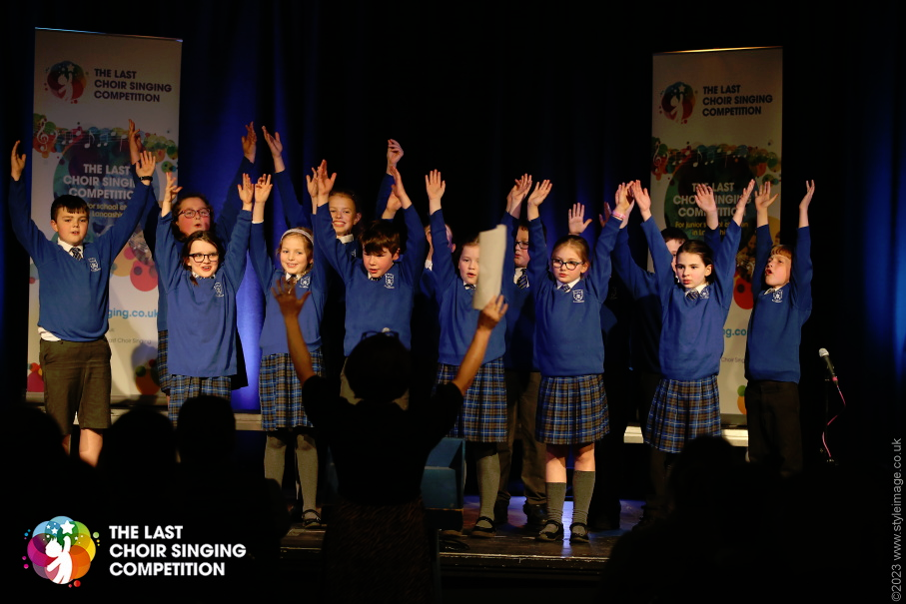 |  | NON-UNIFORM DAY  We will have another non-uniform day on Friday, 10th March this time kindly asking for chocolates and biscuits for our food bingo which is being held in the village hall on Sat 18th March in the evening. Many thanks for all your donations already – you are amazing!  EASTER EGG BINGO  We are holding an Easter Egg bingo in the school hall on Thursday, 30th March from 6pm onwards. There will be refreshments available. More details to follow.  EASTER EGG HUNT / DECORATED BONNET  Our annual Easter Egg hunt will be held around the school grounds on Friday 31ST March. Any donations of small chocolate eggs would be very much appreciated. We will also have a decorated Easter Bonnet competition open to all children from pre-school up to year 6. There will be prizes for all taking part and a main prize for the best one from each class.  EXCITING NEWS  You will probably have heard our very exciting news that Mrs. Jardine is expecting a baby in September. We are all very excited for her and Mr. Jardine and wish them all the very best. In the meantime, the governors and staff will be working together to ensure that Reception and Pre-school are covered from September.
 | Whats Happening? |  | 6th March 2023

Assemblies – Friday 2.45pm
Pre-school and reception – 17th March
Years 4/5/6 – 24th March

Easter Play in School 2.15pm
Led by Years 1/2/3 – 31st March

Sporting Events
Under 9 mini skills 0 14th March
Tag rugby – 21st March
Under 9 mini skills – 14th April
Swimming for year 1 all this half term

Mass at St. Mary’s Church
16th March 9.30am

Events in School this half term (so far!!)

Non-uniform for food bingo – 10th March (chocolates and biscuits please)
Food bingo at the Village Hall, 6.30 doors open – 18th March (eyes down at 7.30pm)
RNLI water safety presentation in school – 21st March (all children)
Year 3 /4 football at Whitechapel – 21st March
Yrs. 4/5/6 to Gawthorpe Hall for Shakespeare Day – 23rd March
Easter Experience at St. Barts – 24th March
Parents Evening in School – 27th March from 3.30pm
History Society – yrs. 4/5/6 – 29th March
Cobble Hey Farm – yrs. 4/5/6 – 30th March
Easter Egg Hunt and Easter Bonnet Competition – 31st March
Easter Egg Bingo in School – 30th March at 6pm

