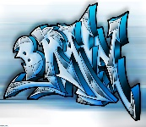

## English – What the Romans did for us (Y4)

This half term block, based around a theme of Escape to Pompeii, consists of two English units:

• Playscripts

• Non-fiction text (Life as a Roman)

## English – Oh! I Do Like To Be Beside The Seaside (Y5/6)

This half term block, based around a theme of the Carrie’s War, consists of two English units:

* Short stories with flashbacks
* Discursive essay

## Music

## Roald Dahl – Cinderella – Singing

Listening to and appreciating the music of Robert Schumann.

Notation and learning notes C, E, F,G, A on tuned instruments.

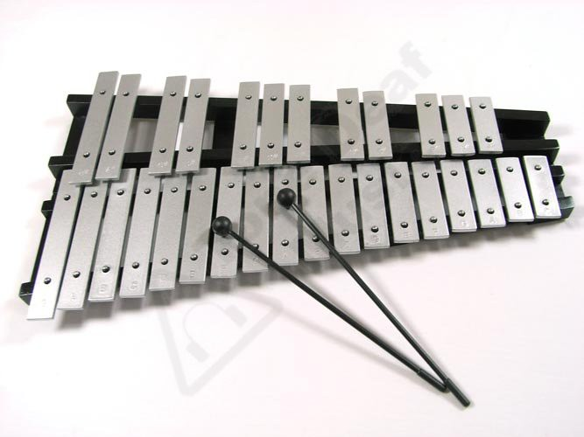

**Enrichment activities**

Abbystead – Learn Moor

Moving on up sessions for Y6

Coronation Garden Party

## PE

Athletics

Striking and Fielding - PNE

**History – Ancient Egypt**

This term we will be exploring the life of Ancient Egyptians between AD and BC. We will investigate social structures, roles and rights, pharaohs, and the pyramids.

**Art and Design – Textiles (Batik)**

All children will design their own Batik style patterned piece with watered down ink to add brighter colour.

**RE – Witnesses (Pentecost)**

Children will be able to make links to show how feelings and beliefs affect their behaviour and that of others when it comes to deciding about being a witness, whilst linking this to the transformation of the Holy Spirit.

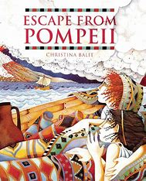 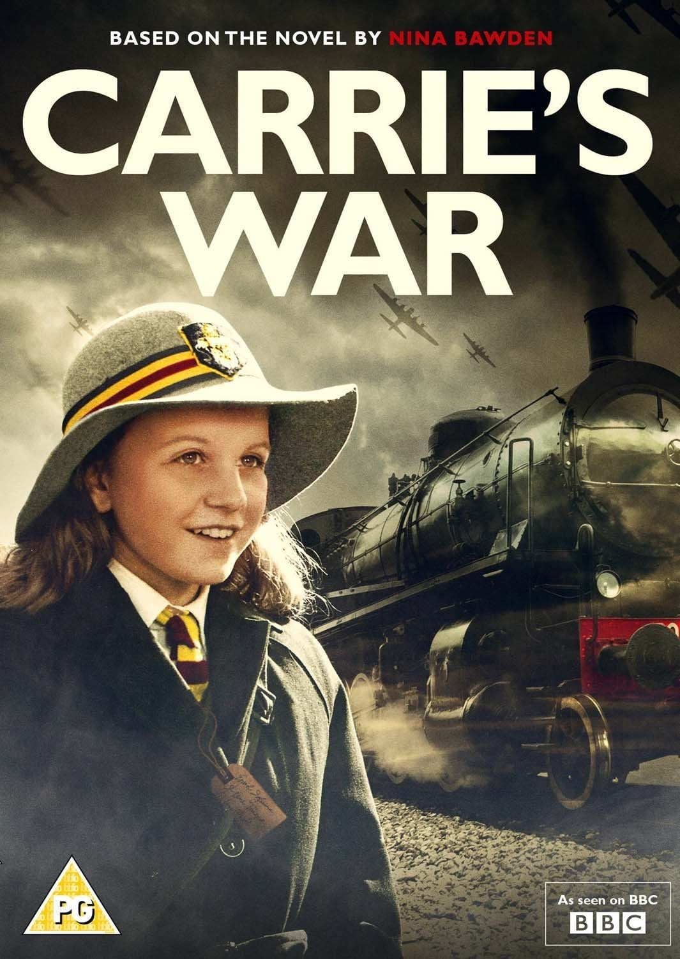

## Maths

**Year 4 –** Decimals, fractions, money, and time.

**Year 5 –** Properties of shape and decimals.

**Year 6 –** Properties of shape and problem solving.

# **Years 4,5,6**

**Summer 1 2023**

**Miss Doherty**

## Science – Light

This term we will be investigating the how travels in straight lines. The children will be able to explain that we see things because light travels from light sources to objects and then to our eyes.

Finally, we will explore reflection and refraction.

**Computing**

Children will identify the purpose of writing a blog. Explore the features of successful blog writing, which will result in writing a blog.

orona