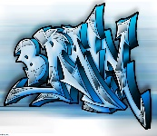

## English – Gulliver’s Travels (Y4)

**This half term block, based around a theme of Gulliver’s Travels, consists of two English units:**

**• Non-chronological reports**

**• Novel as a Theme**

## English – Inventors and Inventions (Y5/6)

**Novel as a Theme – children will write a short story or chapter for a novel about an invention.**

**Magazine – children will write a page for a magazine.**

**RE – Death and New Life**

**This term we will be discussion how loss and death bring about change for people. We will explore the Church’s seasons of Lent, Holy Week and Easter; the suffering, death and resurrection of Jesus led to new life.**

**Hinduism – belonging and values, karma**

**Geography – Field work 2**

**This term we will be observing, measuring and recording physical features in the local area of Chipping.**

## Music

## Ukulele and singing

## PE

**Swimming**

**Throwing and catching - PNE**

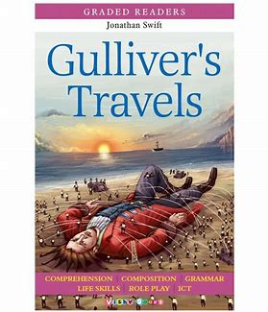 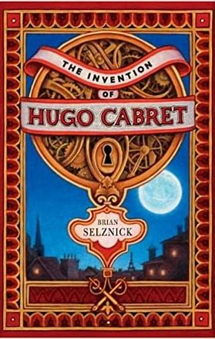

# **Years 4,5,6**

**Spring 2 2023**

**Miss Doherty**

## French

**We can write phrases from memory, and adapt these to create new sentences, to express ideas clearly - describe people and their clothing, food (including likes and dislikes) orally and in writing.**

**Design Technology – Mechanisms (Fairgrounds)**

1. I can look at a range of existing fairground rides and investigate how they move.

2. I can investigate ways of using electrical motors to create rotating parts.

3. I can create prototypemodels to investigate stable frameworks.

4. I am able to design a fairground ride with a rotating part.

5. I am able to make a fairground ridefollowing a design.

6. I am able to evaluate a finished product.

**Enrichment activities**

**Tag rugby competition, cross country competition, History Society Children's project 2023,**

**World Book Day, Last Choir Singing**

## Science – Living things and their habitats

**How are living things classified?**

**Why do we classify them?**

**We can give reasons for classifying them based on specific characteristics.**

## Maths

**Year 4 – Exploring fractions using diagrams.**

**Solving problems involving increasingly harder fractions to calculate quantities.**

**Year 5 - Identify, name and write equivalent fractions.**

**Read and write decimal numbers as fractions.**

**Year 6 – Use simple formulae.**

**Express missing number problems algebraically.**

**Solve problems involving the calculation and conversion of units of measure.**