

## English

## Growth and Green Fingers (Year 1 and 2)

**Classic Stories**

**Instructions**

**Traditional Rhymes**

**The Iron Man (Year 3)**

**Based around the theme of The Iron Man,**

**• Novel as a theme**

**• Recount: diaries**

## Science – Animals including humans; growth and survival

**Find out about a variety of animals and their offspring and ways in which animals reproduce.**

**Explore how humans grow and find out what animals including humans need to survive.**

**Exploring the environment as a factor of survival.**

**Find out how to eat a healthy balanced diet and the importance of exercise.**

**Art and Design –**

**A Ruth Daniels rainforest inspired drawing experimenting with different techniques and mediums.**

**History – The Great Plague**

**Find out when the great plague occurred and place on a timeline. Know the effect it had on Britain. Learn about how it spread.**

**RE – Local Church; Community ‘Books’**

**Learn about the Bible and the Gospels.**

**Find out when the parish family listen to the Gospel and hear from the Gospel of Matthew. Look at other Books relating to the parish family and Mass.**

## Maths

**Year 1 – Addition within 20, Subtraction within 20**

**Year 2 – Multiplication and Division, statistics, Length and Height**

**Year 3 – Multiplication and division, Money, Statistics**

## Computing

## Branching databases;

**Sorting objects using yes/no questions, use programme ‘2question’, creating branching databases of children’s choices**

## PE

**Dance, football, mini skills**

**Swimming (Year 2)**

**Enrichment activities**

**Plague doctor visit, mini skills, football competition**

# **Years 1,2,3**

**Spring 1 2023**

**Mrs Cowburn**

## PSHE – Health and Wellbeing

**Belonging to a group; roles and responsibilities; being the same and different in the community**

**The internet in everyday life; online content and information**

**What money is; needs and wants; looking after money**

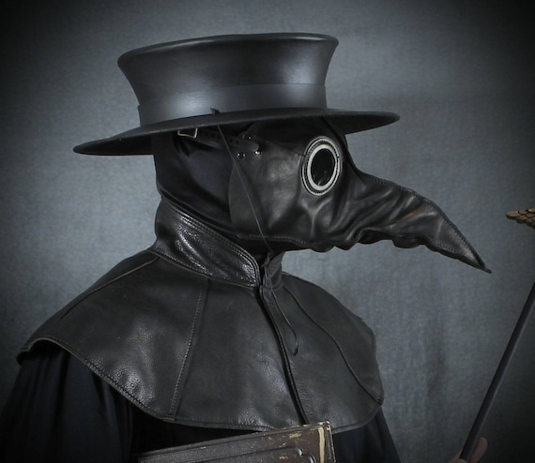

Year 1 will continue to access continued provision and build on the Early Learning Goals.