St. Mary’s Primary and Pre-school Newsletter | 5th September 2022
welcome back  We hope you have all had an amazing summer holiday and that the children are ready to get back to school. The staff are all refreshed and we are looking forward to seeing all our lovely children. We are also looking forward to receiving our OFSTED report any time soon. We will share it with you as soon as we can. We also welcome into school our new reception children Sienna, Ebba, Lydia, John, Joseph and Samuel. Samuel and his big sister Diamond in year 2, will be moving into our community in a few weeks’ time, so I know that you will all welcome them into our St. Mary’s community.  WELCOME MEETING  As previously mentioned, we are holding a ‘welcome back to school’ meeting for parents on Wednesday, 7th September at 5pm to discuss our curriculum, homework, expectations etc. Mrs. Morris will lead the meeting from 5pm and then she will invite you to go into your child’s classroom to have a look around and to listen to your child’s class teacher talk about what will be happening in there and give you an opportunity to ask questions too. Ideally, this is for parents only, but if you don’t have child care, then of course you may bring them. | WINMARLEIGH MEETING  Children in years 4/5/6 will be going to Winmarleigh, outdoor pursuits residential on Monday, 10th October. There will be a meeting in school for parents and children to discuss what they need to take and what to expect on Wednesday, 28th September at 5pm.  FRIENDS OF ST MARY’S  FOSM have organized our next tribute night with ‘Legends of Sound’ at Chipping Village Hall on Sat, 1st of October. Tickets are £14 each. This is always a fantastic night and proceeds do go back to school and our children. Please do come along if you can.
What’s Happening? | 5th September 2022

Wednesday 7th September – Parents Welcome Meeting in School 5pm
Thursday 8th September – Mass in Church 9.30am
Wednesday 28th September – Winmarleigh Meeting 5pm
Friday 30th September – Macmillan Coffee Afternoon 2.30pm
Saturday 1st October – Legends of Sound, Chipping Village Hall 7pm
Tuesday 4th October – Tempest Photos in School 8.30am
Thursday 6th October – Mass in Church 9.30am
Monday 10th – Wed 12th – Years 4/5/6 to Winmarleigh
Friday 21st October - Open Morning 9.30am – 11.30am
Break up for half term holiday

Celebration assembly will continue every Friday afternoons at 2.45pm for parents, friends and family to join us with the successes of the week. Over the next few weeks, we will organise special class assemblies.
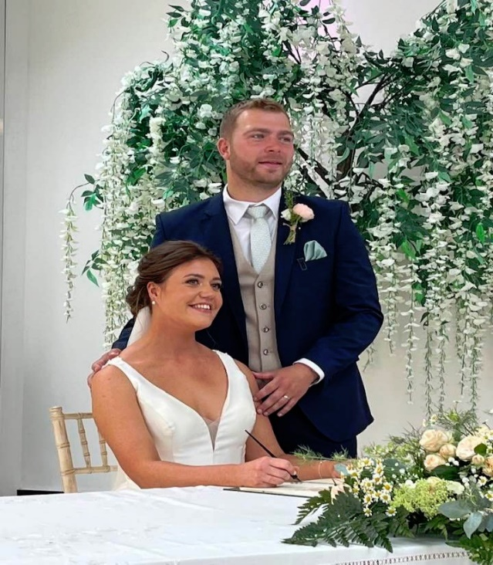

Congratulations to Mr. and Mrs. Jardine,
who got married at the beginning of the
summer holidays. We would like to wish them
all the very best for the future.

