St. Mary’s Primary and Pre-school Newsletter | 3rd October 2022
Jeans for genes Day  Thankyou for supporting this great cause. We raised just under £50 which was sent off to the charity.  MACMILLAN COFFEE AFTERNOON  Thankyou for those parents and grandparents who were able to support our MacMillan coffee afternoon last Friday. We managed to raise an amazing £128.  SCHOLASTIC BOOK FAIR  We will be holding a scholastic book fair in the school hall from Thursday the 13th October until Tuesday the 18th of October. It will run after school from 3.15pm until 4pm every night. There will be three cases of books to buy for all age ranges and genres of readers. They can be bought as Christmas presents or just to simply encourage your child to keep reading. We do take a percentage of the takings so it is a money making scheme for us as well – we tend to then buy books with the credit we have made so it all goes back to our children. Please do come along and support where you can.  WINMARLEIGH MEETING  Children in years 4/5/6 will be going to Winmarleigh, outdoor pursuits residential on | Monday, 10th October. Please can you make sure that you have paid the balance of this otherwise, school will have to pay for it out of our school funds.  BISHOP JOHN ARNOLD  We are very excited to announce that Bishop John Arnold, from Salford Diocese, will be visiting our school on Wednesday, 2nd October to officially open our new kitchen. He will preside over Mass at St. Mary’s Church at 9.30am first thing and you are all welcome to join us there. The children will be going to Mass and it would be wonderful to have your support in Church whether you are a member of the Catholic Church or not. He will then come back to school where we will show him around before we officially ‘open’ the kitchen. Hopefully, he will be able to stay for lunch. More details to follow soon.  HARVEST LUNCH – 21st OCTOBER  We would like to invite one family/friend per family to join us for our Harvest Lunch on Friday, 21st October. It will be soup, sandwiches and cake. In return, we ask that you send in tins and dried goods e.g. rice, pasta etc. for us to make up harvest hampers for our older children to distribute out to our community. We are happy to start accepting this as soon as possible. Invites for lunch will be coming home soon.
Whats Happening? | 3rd October 2022

Tuesday 4th October – Tempest Photos in School 8.30am
Thursday 6th October – Mass in Church 9.30am
Friday 7th October – Pre-school and Reception leading celebration assembly, 2.45pm
Monday 10th – Wed 12th – Years 4/5/6 to Winmarleigh
Tuesday 11th – mini skills at West View Leisure Centre
Wednesday 13th – 18th October, Scholastic Book Fair in Hall every afternoon 3.15pm until 4pm
Friday 14th October – Years 4/5/6 leading class assembly, 2.45pm
Wednesday,19th October – Flu Vaccines in School
Thursday, 20th October – Hockey Tournament at UCLAN
Friday 21st October – Harvest Lunch (one guest per family)
Break up for half term holiday
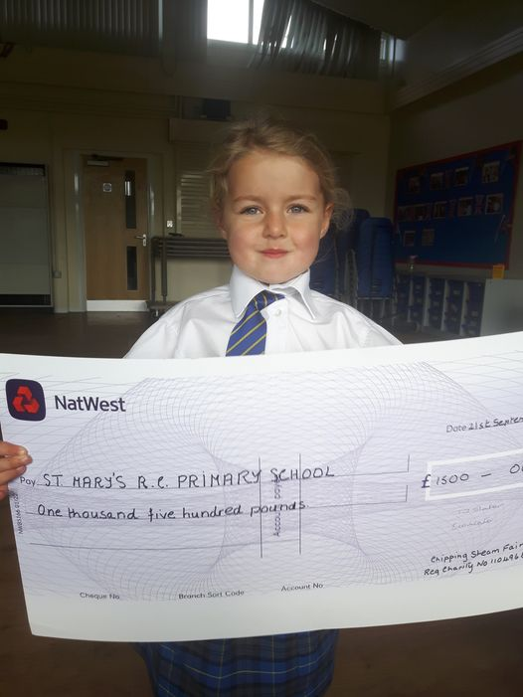

And finally……… Chipping Steam Fair
very kindly gave us £1500. We are
extremely grateful to them for this
kind gift and we are having discussions
about how we can use it to benefit
everyone in school.

