St. Mary’s Primary and Pre-school Newsletter | 20th September 2022
Jeans for genes Day  We will be inviting the children and staff to come to school in jeans this Friday, 23rd September and to bring a donation of a £1 or so for us to donate to this wonderful charity.  Funding In Action  Some genetic conditions are apparent at birth whilst others are diagnosed at different stages throughout childhood, adolescence and sometimes into adulthood, having a profound and lasting impact on individuals and their families.  Our ambition is that every individual, and their families, can access the right support at times when it’s needed most. By taking part in Jeans for Genes week, we can all work together to make this ambition a reality.  MACMILLAN COFFEE AFTERNOON  We would like to invite you into school on Friday, 30th September form 2.30pm to celebrate our MacMillan Coffee Afternoon with us. The children will be baking cakes and biscuits during the week so we will not be asking for donations of cakes this time. Instead, please do come along and the children and staff will serve you. | WINMARLEIGH MEETING  Children in years 4/5/6 will be going to Winmarleigh, outdoor pursuits residential on Monday, 10th October. There will be a meeting in school for parents and children to discuss what they need to take and what to expect on Wednesday, 28th September at 5pm. The final payment is due on ………  FRIENDS OF ST MARY’S  FOSM have organized our next tribute night with ‘Legends of Sound’ at Chipping Village Hall on Sat, 1st of October. Tickets are £14 each. This is always a fantastic night and proceeds do go back to school and our children. Please do come along if you can.
What’s Happening? | 20th September 2022

Friday 23rd September – Jeans for Genes Day (for a donation come to school in jeans)
Wednesday 28th September – Winmarleigh Meeting 5pm
Wednesday 28th September – PTFA meeting in school 5.30pm
Thursday 29th September – Kids Football Cup at Play Football 9.30am – 3pm
Thursday 29th September – Reception Class Photo – Lancashire Evening Post (1pm)
Friday 30th September – Macmillan Coffee Afternoon in school 2.30pm
Saturday 1st October – Legends of Sound, Chipping Village Hall 7pm
Tuesday 4th October – Tempest Photos in School 8.30am
Thursday 6th October – Mass in Church 9.30am
Friday 7th October – Pre-school and Reception leading celebration assembly, 2.45pm
Monday 10th – Wed 12th – Years 4/5/6 to Winmarleigh
Wednesday 13th – 18th October, Scholastic Book Fair in Hall every afternoon 3.15pm until 4pm
Friday 14th October – Years 4/5/6 leading class assembly, 2.45pm
Friday 21st October – Harvest Lunch (children to invite one guest each)
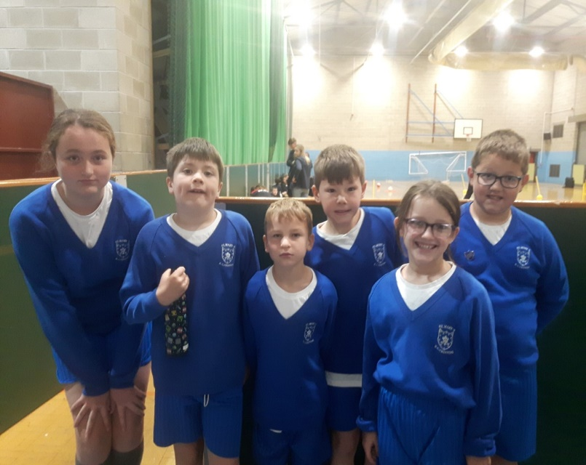
Break up for half term holiday

Here is our fantastic mini skills team
that took 3rd place at our first
tournament of the year at West
View this morning. Well done to them
for their great participation and
sportsmanship and also to the rest of
the class who went along to cheer
them on.

