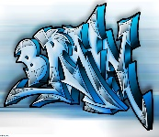

## English – Amazing Birds (Year 1 and 2)

**Non-Chronological Reports – children will research about and write a non-chronological report about Owls.**

**Narrative – children will write a story based on a theme; focus text ‘The Owl Who was afraid of the dark’.**

**Grammar – concept of a sentence, subordination for reason using ‘because’.**

**Rock and Roll (Year 3)**

**Narrative – children will write a story based on a theme; focus text ‘Stig of the Dump’.**

**Poems on a theme – children will learn poems by heart and write a poem based on a structure.**

**Grammar – prepositions used within sentences, e.g. above, below, beneath, within. Use knowledge of root words to understand meanings of words, e.g. volcano, volcanic.**

Year 1 will continue to access continued provision and build on the Early Learning Goals.

**Enrichment activities**

**Big Garden Bird Watch**

**National Storytelling Week**

**Chinese New Year**

**Children’s Mental Health Week**

**Winter Olympic activities**

**Safer Internet Day**

**Art and Design - Drawing**

**Work on concentric circles experimenting with colour. Creating a drawing / painting using concentric circles in the style of Kandinsky’s tree art. Work in a schematic and observational way placing objects to create the desired outcome.**

# **Years 1,2,3**

**Spring 1 2022**

**Mrs Cowburn**

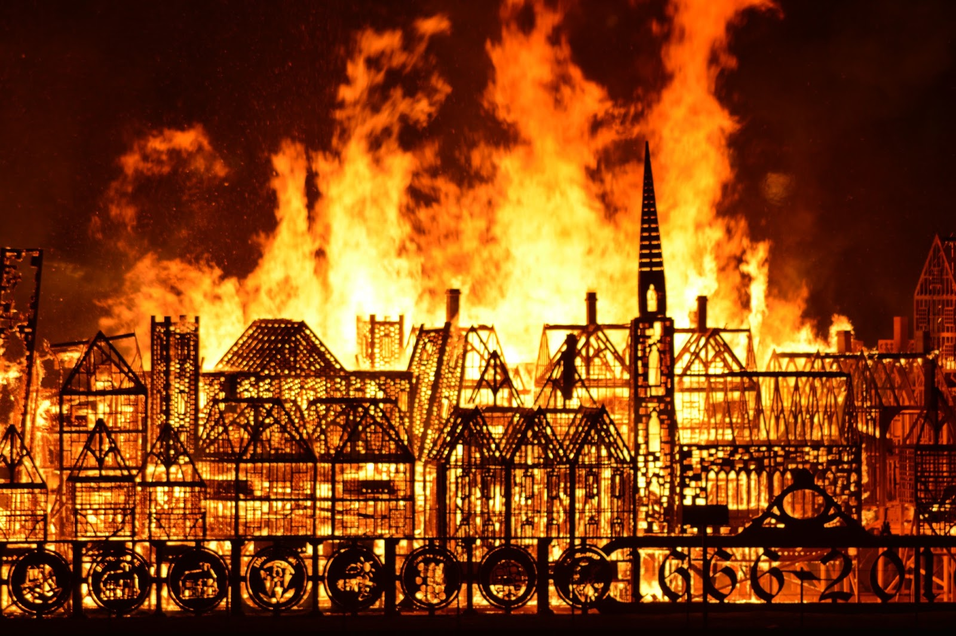

**RE – ‘Journeys’**

**Children will be learning about the Liturgical Year, the seasons of the Church’s Year, the feasts of Our Lady, how Jesus wants us to love one another and the Christian’s life journey of prayer.**

**Islam - Inside the mosque.** **The activities at the mosque.**

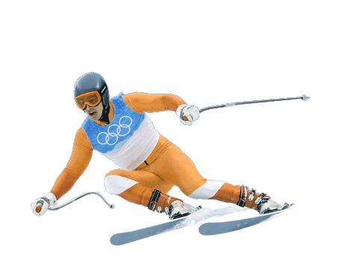

**History – The Great Fire of London**

**Children will learn where and when the Great Fire of London started, understand the events of the fire through undertaking research activities, find out why the fire spread so quickly and learn about Samuel Pepys.**

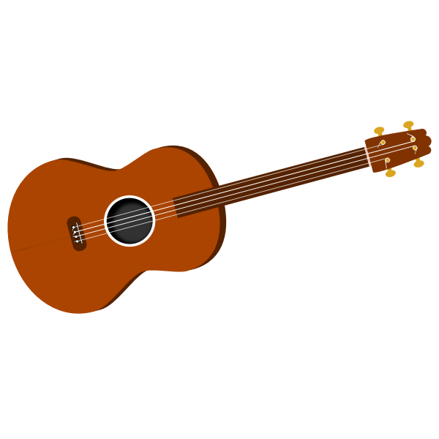

**Music**

**Ukulele lessons**

## French

## Numbers 0-20

**Playground Games**

## PE

**Dance ‘Explorers’**

## Science – Everyday Materials

**Children will be learning how to distinguish between an object and the material it is made from. They will be able to identify and name a variety of everyday materials including wood, plastic, glass, metal, water and rock. Children will describe simple physical properties of everyday materials and will compare and group a variety of everyday materials.**

## Maths

**Year 1 – Addition within 20, Subtraction within 20**

**Year 2 – Multiplication and Division, statistics, Length and Height**

**Year 3 – Multiplication and division, Money, Statistics**