St. Mary’s Primary and Pre-school Newsletter | 4th January 2022
Happy new year  Welcome back to school after the Christmas holidays. We hope that you have all had a peaceful and joyous time with your families.  We move into 2022 with hope that this year will be positive and that there are less restrictions for everyone. On behalf of our PTFA, ‘Friends of St. May’s’ we have been asked to publish the following message……..  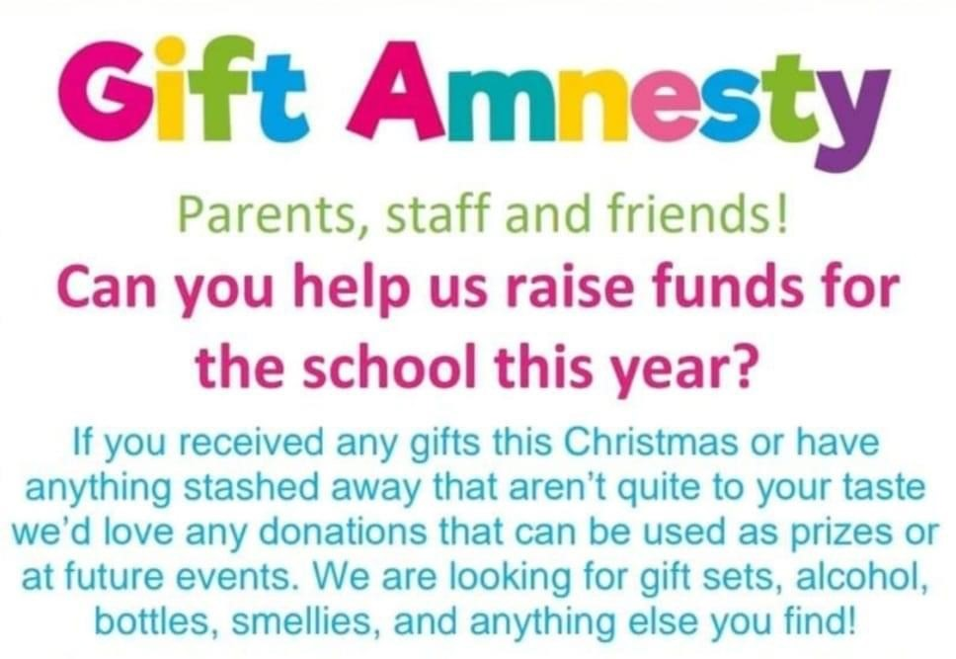  Can we politely remind parents that school begins at 8.55am and that the children need to be here on time. Children turning up late for lessons disrupts everyone in the classroom and school.  PE kits also need to be in school at all times. We are happy for them to have long jogging bottoms and hoodies for the winter months as long as they have their blue shorts and white t-shirts as well for indoor PE lessons. Please can you check that their kits fit them still including their trainers or pumps.  Swimming this term is for years 4,5,6. They will start again on Friday, 14th January. | Assemblies – 2.30pm  We would like to invite parents and friends of our children into school to share our Celebration Assemblies on the following dates at 2.30pm.  Pre-school and Reception – 28th January  Years 1,2,3 – 4th February  Years 4,5,6 – 11th February  Please can we ask that you only attend the assemblies in which your child is taking part in for now. We are desperate to keep everyone in school for as long as we can so if we take small, measured steps, this may hopefully reduce the chances of Covid transmissions.  READING BOOKS  As we move into the Spring term, we are having a big push on reading in school and at home. We are asking the children to bring a bag into school with their reading book and reading record every day. If they have lost them, we will replace them this week. Please can you ensure that all your children are reading at home for at least 10 minutes every day and that you sign their records to let us know that they have done so. We will also be doing guided reading in school most days where the children will be reading in small groups. If you need more books, please do ask. Reading has always been a strength at St. Mary’s and we are proud of the children’s achievements in reading and comprehension skills, therefore, we are going to be starting to award prizes to children for reaching various reading targets. More details to follow soon.
What’s Happening? | 4th January 2022

CHEESE AND WINE EVENING

Friends of St. Mary’s are holding a cheese and wine night in the school hall on Friday, 28th January from 7pm. Tickets are £16 each. Please let us know if you would like tickets. They are limited so do let us know if you want tickets ASAP to avoid disappointment. They will need to be paid for to secure your reservation.

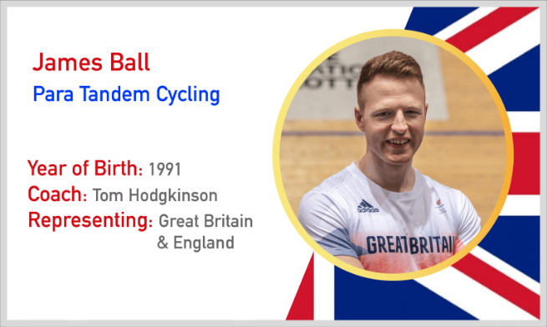

SPORTS FOR CHAMPIONS

On the 10th of February, we welcome James Ball,
Para Olympian, into school to talk to our children about
being an Olympian and also to do a sponsored fitness
circuit. Some of the sponsor money that the children raise helps to support these athletes as they progress in their sporting careers. The children will be bringing home a sponsor form and any money raised is gratefully received.

MUSIC LESSONS

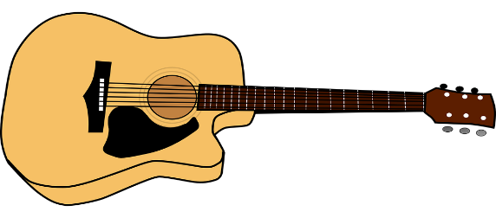
Unfortunately, Mr. Hawkes will be unable to continue piano lessons in school as he is planning to move house. We thank him for all his hard work with our children who have all made super progress with him and wish him all the very best. In the meantime, we will be looking for another piano teacher to take over from him and will keep you all informed. In the meantime, we are very excited to welcome the ‘We Create Music’ company into school who will be working with all our children from years 1 up to year 6 over the Spring term. Children in years 1,2,3 will be having 6 hours of ukulele lessons this half term in school and then years 4.5.6 after the half term holiday. ‘We Create Music’ are also offering a free guitar taster lesson on Wednesday 5th January with a view to starting lessons next week. We already have a handful of children who are interested in the taster session but we will include any children that would like to have a try.

