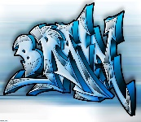

## English – Fighting Fit

**Traditional tales with a twist – we will learn how to write an innovated traditional tale with a twist.**

**Instructions – we will write a set of instructions for a new playground game**

**Grammar – we will say, write and punctuate simple and compound sentences using joining words *and, but, so, or: s*elect, generate and effectively use verbs; use past tense in narrative; select, generate and effectively use adverbs.**

## Maths

**Year 1 – Addition and subtraction within 10, 2D and 3D shapes.**

**Year 2 – Addition and subtraction, Money, Multiplication and Division.**

**Year 3 – Addition and subtraction, Multiplication and Division.**

# **Years 1,2,3**

**Autumn 2 2021**

**Mrs Cowburn**

## Science – Animals including humans

**Children understand that animals need to eat in order to get the nutrients they need. What nutrients does food contain and what is a balanced diet?**

**Understand that humans, and some other animals, have skeletons and muscles which help them move and provide protection and support.**

**Design Technology – Textiles**

**The children will learn about textile vocabulary. They will cut shapes which have been drawn on fabric using a template. They will learn how to join fabrics in a variety of ways and create prototypes. They will decorate fabrics using appropriate techniques.**

**Enrichment activities**

**Anti-bullying week, Parliament week, Enterprise week, nativity performances, shoe box appeal, Christmas jumper day.**

**RE - Visitors**

**Advent is a time of preparation for the coming of Jesus at Christmas. The meaning of the Jesse tree. Isaiah foretells the coming of the Messiah. The joys and demands of being a Christian. The stories of the Annunciation and the Visitation. The story of the birth of Jesus and the visit of the shepherds. (Luke) The visit of the Wise Men. (Matthew) An understanding that Jesus came to Earth for the good of all.**

**Judaism – we have an understanding about the synagogue.**

## PE

**Gymnastics / Swimming**

**Invasion and Fundamental Movement Skills**

## Computing

## Online Safety and Coding

**Geography – Our European Neighbours**

**We know different countries and their capital cities in Europe and can describe the features. We can also compare two European capital cities.**

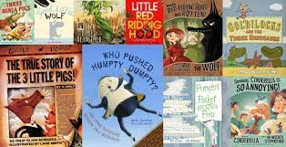

**Music - Hands, feet, heart**

**We will learn different dimensions of music including pulse, rhythm and pitch. We will also be singing and playing instruments. As well as learning to sing, play, improvise and compose with this song, children will listen and appraise different styles of South African music. They will also learn about the composer Sergei Rachmaninov and the music that he composed**.

Year 1 will continue to access continued provision and build on the Early Learning Goals.