St. Mary’s Primary and Pre-school Newsletter | 11th October 2021
Welcome back to school  We welcome Miss Jones back to St. Mary’s this week as she begins her PGCE placement with us in Miss Taylor’s class. She will be with us for four weeks. We hope she settles in quickly and we all look forward to working with her.  FLU VACCINE  The school nurses will be in school on Wednesday, 20th October to administer the flu vaccine to children whose parents have given their permission. The vaccine is a nasal spray and takes a couple of seconds to give.  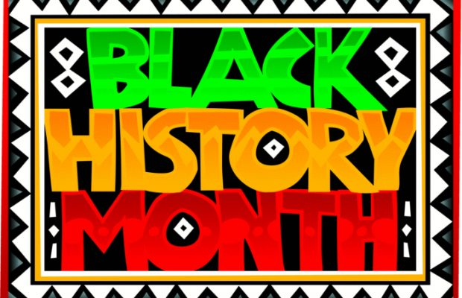  BLACK HISTORY MONTH  As part of ‘Black History’ month, we will be welcoming Burnley Football club into school on Friday, 22nd October to talk about racial equality and we will be learning about what Black History Month is, how it’s celebrated and explore some influential figures from the Black Community. We will then look at the history of black men and women in football in England. | Assemblies  Thankyou to the parents of years 4/5/6 who were able to join us for assembly last Friday. It was wonderful to welcome you all back into school. This Friday, it will be year 1/2/3 assembly starting at 2.30pm.  October 15th-years 1/2/3  October 22nd–pre-school/reception  November 26th–years 4/5/6  December 3rd-years 1/2/3  December 10th–Pre-school and Reception  Please can we ask that you only attend the assemblies in which your child is taking part in for now. We are desperate to keep everyone in school for as long as we can so if we take small, measured steps, this may hopefully reduce the chances of Covid transmissions.  PARENTS EVENING  There will a parents evening next Monday, 18th October from 3.30pm until 6pm that will give you the opportunity to talk to your child’s class teacher. Mrs. Cookson is now taking bookings. Please contact her on her email address, bursar@st-marys-chipping.lancs.sch.uk if you haven’t got a time slot yet.  HALF TERM HOLIDAY  We break up for the half term holiday on Friday 22nd of October and return on Tuesday, 2nd November. Monday the 1st of November is an INSET day.
What’s Happening? | 11th October 2021
Headteacher for the DAY  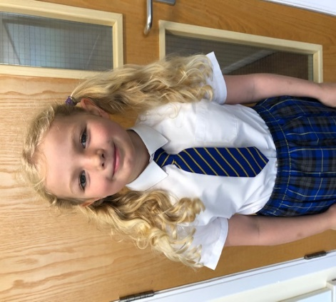  Before the pandemic started, Emily Eastham won a competition at our school BBQ to become head teacher for the day. Unfortunately, due to circumstances, we haven’t been able to honour this until now! So…… on Friday, 22nd October, Emily will be in charge. Her first decision is that it will be non-uniform for the day. Mrs Morris is NOT happy about this, however, she has to listen to the boss! Emily also wants to do some baking, have extra long playtimes and watch a movie! There are going to be some negotiations we think. However, we know that Emily will do an amazing job and we look forward to her taking on the role.  ANTI BULLYING WORKSHOP  On Wednesday, 10th November, all children in school will be taking part in an anti bullying workshop with an outside theatre company that  teach their lessons through drama. We will also be doing other activities during the week linked to this very important theme. | open Day  On Friday, 5th November we will be holding our open day from 10am until 5pm. This is an opportunity for new families to come and have a look at our school. If you know of anyone who may be interested please let them know. We are asking that they kindly ring up to make an appointment.  HEAD LICE  We still have an ongoing problem with head lice in school. Please can you ensure that you are checking your children’s hair on a daily basis and that any child with long hair has it tied back. Please can you also let us know if you are struggling with this at home as we can let parents know without naming any children.  SECOND HAND SCHOOL UNIFORM  The ‘Friends of St. Mary’s’ are holding a second hand uniform stall on Friday 22nd October at the end of the school day. They will be selling donated school uniforms for a small fee. If you have any unwanted clothes, please do donate them so that they can be recycled and reused. You can either drop off at school or pass them onto Emma Baines.  