

## English – The Place Where I live

**Stories with a familiar setting – children will learn how to sequence main events in a story using the Jolly Postman story as a stimulus.**

**Non-chronological reports – children will write a report linked to an aspect of the local area after learning how information is organised in non-fiction texts.**

**Grammar – say, write and punctuate simple and compound sentences and joining words**

**Create compound words using nouns.**

# **Years 1,2,3**

**Autumn 1 2021**

**Mrs Cowburn**

## Science – Seasonal Changes

**What is the weather like during each season?**

**What are the four seasons?**

**How and why does our shadow differ at different times of the day? How does different types of weather affect our lives?**

**History – Local History**

**What were houses and schools like a long time ago in Chipping? What were the games, equipment and household objects like then?**

## MFL

## Greetings and Numbers 0 -20

## PSHE – Health and Wellbeing

**What and who helps us to stay healthy and safe?**

**How do we recognise our feelings? How can we manage risk in different places?**

**RE - Family and Homes**

**What is a Christian home and God’s vision for everyone in it? How do Paul’s letters to the Christians teach us this vision?**

**Judaism – we have an understanding about the synagogue.**

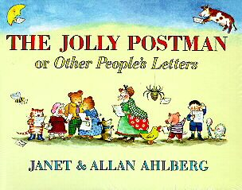

Year 1 will continue to access continued provision and build on the Early Learning Goals.

**Enrichment activities**

**Harvest boxes for the community, anti-bullying week, Black History month,**

**Fair Trade Friday.**

**Art and Design – 3D Form**

**We can use simple shapes to make sculptures of the human form using different materials, drawing on work inspired by Anthony Gormley, Henry Moore and Barbara Hepworth.**

## PE

**Gymnastics**

**Fundamental Movement skills**

## Maths

**Year 1 – Numbers to 10**

**Part whole numbers within 10**

**Addition and subtraction within 10**

**Year 2 – Numbers to 100**

**Addition and subtraction**

**Year 3 – Place value within 1000**

**Addition and subtraction**