St. Mary’s Primary and Pre-school Newsletter | 10th May 2021
ascension day 13th May  Ascension Day celebrates Jesus's ascension to heaven after he was resurrected on Easter Day.  He appeared first to Mary of Magdala. She went and carried the news to his mourning and sorrowful followers, but when she told them that he was alive they did not believe her. Later he appeared to two of the disciples as they were walking into the countryside. They also went and took the news to the others, but again they did not believe that the Lord was alive.  Then, when the eleven disciples were at the table. He appeared to them and reproached them because they had not believed those who had seen him after he was raised from the dead. Then he said to them: 'Go forth to every part of the world, and proclaim the good news to the whole creation. Those who believe it and receive baptism will find salvation; those who do not believe will be condemned, Faith will bring with it these miracles: believers will cast out devils in my name and speak in strange tongues; if they handle snakes or drink any deadly poison, they will come to no harm; and the sick on whom they lay their hands will recover.' So, after talking with them the Lord Jesus was taken up into heaven, and he took his seat at the right hand of God.  Half term holiday is 31st June until 4th June | mental awareness week  Mental Health Awareness Week takes place from 10 to 16 May 2021. This year, we are being invited to immerse ourselves in the '5 Ways to Wellbeing', while reconnecting with nature across the week. The ‘5 Ways to Wellbeing’ are a set of pillars which are key to improving our mental health.  Connect  Be Active  Take Notice  Keep Learning  Give  We will be looking at these five pillars in school this week and discussing what we can do to remain positive and healthy.  EASY FUNDRAISING  Friends of St. Mary’s (PTFA) have asked us to encourage you all to sign up to the easyfundrasing web page for our school. It is really easy to do it and it makes money for our school (and more importantly, our children) So far it has raised nearly £900 which is a superb amount. Just type in easyfundrising and then St. Mary’s RC Primary School, Chipping and you can then sign in.
What’s Happening? | 10th May 2021
royal mail stamp competition  The children in school are taking part in the Royal Mail Stamp design competition. They have to design a stamp that honours the heroes of the coronavirus pandemic. We have had some excellent entries so far. The ones below are a couple from Miss Cookson’s class – Daisy M and Lacey S. Good luck to everyone taking part – their design may be made into a stamp.  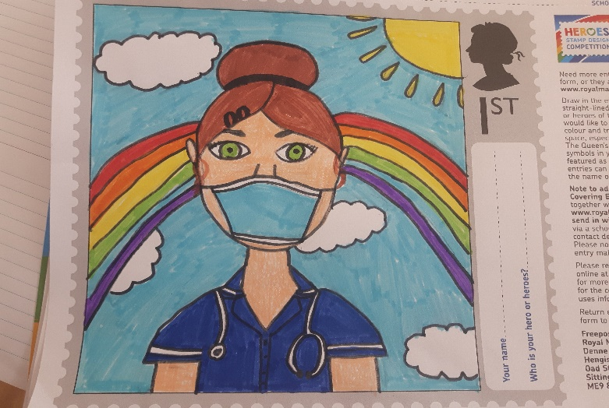  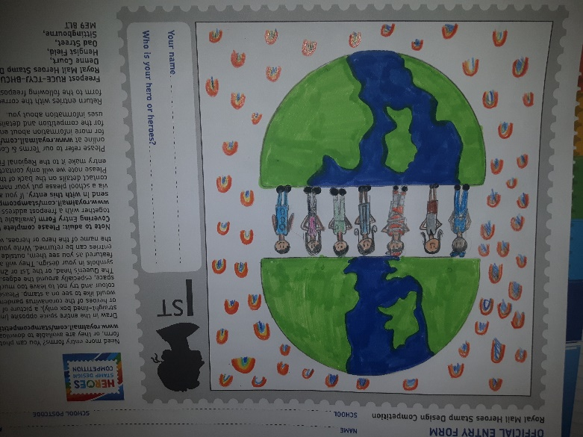 | stars of the week  April 30TH / May 7th  All of Miss Taylor’s class for making Miss Varachhia feel so welcome.  Blayden for always being kind and putting others first.  Harvey for working so hard and putting 100% into everything he does.  Freya for being so kind and helpful.  Ava for an excellent attitude towards reading and writing.  Sophie for being such a good role model.  