St. Mary’s Primary and Pre-school Newsletter | 25th April 2021
Cancer research  Alice and Emily would like to organise a sponsored activity day on the last day of this half term to raise money for Cancer Research. Their very much-loved auntie has recently been diagnosed with breast cancer and is currently undergoing treatment for it. As a school community we send our love and best wishes and pray that she makes a speedy recovery soon. Being proactive as always, the girls would like to raise a target of £200 towards this super charity. They will be producing and printing off a sponsor sheet for all our families who would like to help. They are planning to organise a wheelie around the playing field (scooters, bikes, roller skates, trikes – anything on wheels really!) a bake sale and other activities on the day. If each family could raise £10, they would easily smash their target of £200. Sponsor forms will be coming home soon with more details to follow.  School breaks up on Friday 28th May at 3.15pm. We return on Monday, 7th June at 8.55am. This is a 7-week term. | PARENT CONSULTATION SURVEY FOR RELATIONSHIP EDUCATION  We sent home a parent consultation survey for you to complete about the new statutory relationships curriculum that has come into place this year before the Easter holidays. We plan to begin this term so if you have any questions about it please do look at the link for ‘Life to the Full’ the scheme that we will be using to teach this subject. Most of this curriculum is statutory (meaning that we have to teach it to ALL our children) However, there are some units later in years 5/6 that you can request your child does not take part. When we get to those areas, we will let you know beforehand exactly what is being covered and how it is being covered. You can then make an informed choice about whether or not you want your child to participate. As always, parents are their children’s first and most important educator.  EASY FUNDRAISING  Friends of St. Mary’s (PTFA) have asked us to encourage you all to sign up to the easyfundrasing web page for our school. It is really easy to do it and it makes money for our school (and more importantly, our children) So far it has raised nearly £900 which is a superb amount. Just type in easyfundrising and then St. Mary’s RC Primary School, Chipping and you can then sign in.
What’s Happening? | 25th April 2021
Easter celebrations  Thank you so much for all the generous donations of eggs for our easter egg hunt. We had a superb afternoon in the beautiful sunshine looking for eggs.  Curriculum  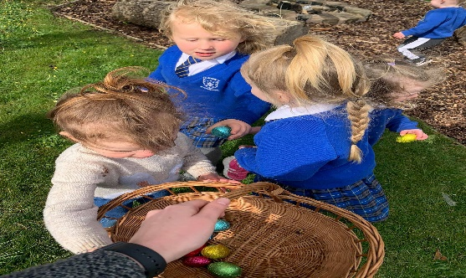  We will continue with our three-year curriculum overview which is on our school web site page under parents and then curriculum. If you have any questions about curriculum coverage and content, please contact your child’s class teacher or Mrs Morris. Please can we ask you to continue listening to your children read regularly at home and to help them with their spellings where possible. We will arrange another parents meeting in the second half of the summer term either remotely or in person depending upon where things are. However, if you have any worries or concerns, please do get in touch asap. | stars of the week  April 16TH / 23rd  Harry for amazing independent writing  Sebby for setting an excellent example  Alice for her wonderful artistic skills  Arthur for taking great care with his work  Archie for becoming such an independent learner  Anna for her amazing confidence at swimming  