St. Mary’s Primary and Pre-school Newsletter | 9th March 2021
Welcome back!  It was wonderful to welcome back all our children yesterday. They and the staff have been sorely missed in school and we were all so pleased to see them back in their classrooms with their friends. We know that for some families this will feel a little strange and some will have mixed feelings moving ahead. However, it is one step at a time. Please can we remind you all to remember the rules about not mixing with other people inside and outside of your homes until we are directed to do so. We are desperate to keep everyone in school after all this time of having to stay at home and to have to isolate now would be devastating. We are almost there. All staff will continue to test twice weekly.  Please can we remind you that school starts at 8.55am. Please be on time. Also, unless your child is in breakfast club, please do not arrive before 8.45am either as there will not be a member of staff on duty in the playground until then.  We are so pleased to announce that our trout eggs have now hatched and we have 20 trout parr. It is less than we had hoped for however,  The River’s Trust people are pleased with them and are keeping a watchful eye on them. Miss Cookson’s class will now begin to feed them. More to follow. | Potions and spells  This week we will be combining National Science Week with last weeks World Book Day. The children will be working on lots of chemistry based experiments  As they explore potions and spells, culminating in a magical book character dress up day on Friday. We look writing up lots of experiments and spells and talking and discussing these wonderful book characters. Please check out our Facebook page for lots of photos this week.  SCHOOL PRIORITIES  Over the next few months, we will be working hard in school to get all our children writing for resilience and at length – according to their age and ability. Any opportunities that you have at home to get them writing – please do so. They could write out recipes from cook books, write in a diary, write a letter to a family member or simply just copy a page of text from a story book. The more they can write, the easier and faster it becomes for them. If you are unsure of letter orientation please contact your child’s class teacher for help.
What’s Happening? | 9th March 2021
Easter plans – Friday 26th March  As always, we are going to hold our Easter Egg Hunt around our school grounds on Friday, 26th March. This is when the Easter bunny hides eggs around the gardens and the children then go out to find them. If you would like to help the Easter Bunny by donating some small chocolate eggs for him / her to hide, we are sure he/she will appreciate that very much! If you could send them in the week beginning the 22nd March that would be brilliant. Thankyou in anticipation.  Also, some of our children have requested that we have a decorated egg and decorated Easter bonnet competition. All children from pre-school up to year 6 can take part in both or either. Prizes will be given out to every child for taking part and then there will be year group prizes for the most original / independently worked upon eggs and bonnets.  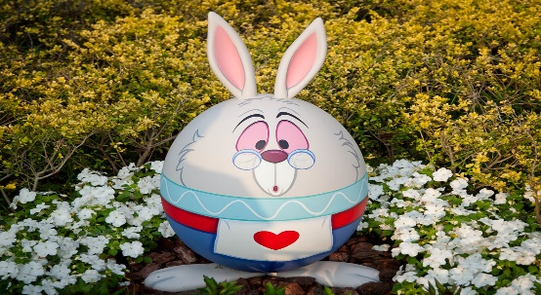 | We will have the Easter Bonnet parade around school. It’s a bit of fun and signifies Easter coming. Again, we will judge this on Friday, 26th March but your child can bring them in earlier in the week if it helps.  COMMUNITY GARDENERS  Many thanks to our community gardeners who are working hard on our school grounds. They have put in several fruit trees and rose plants. It is going to be spectacular when it all gets going. Hopefully soon, you will all be able to come back into school to see what they have done. The children as always, will be involved with the gardening and will be helping out with the veg patch as it warms up.  