St. Mary’s Primary and Pre-school Newsletter (5) | 3rd November 2020 – published every two weeks
Welcome back to school  Welcome back to school after the half term holiday. We hope that you have had  a peaceful week and that the children are  well rested and ready to start again. We especially would like to welcome Amelia into our reception class. Amelia and her grandma have just moved into the village and we know they will be made welcome by all of our school family and friends. Thank you especially to Julie Neary for helping to get them organised with somewhere to live. We hope they both settle in quickly. This half term is 7 weeks long and we break up for the Christmas holidays on Friday, 18th December.  Anti- bullying Week  November 16th sees the beginning of National Anti-bullying Week. The theme this year is  ‘United Against Bullying.’  We will be discussing this in school during the week and doing workshops on it. Please talk to your child about this very important issue.  AFTER-SCHOOL CLUBS  After-school clubs begin today and run for 7 weeks. The last one is on Thursday, 17th December. | School Christmas video  We are hoping to film our Christmas video on either Thursday 19th November or Friday 20th November. Pre-school and reception children are performing a short nativity and years 1/2/3 and 4/5/6 will be performing Christmas carols and songs in their ‘bubbles’ An order from will be coming home this week for you to order DVDs or flash drives. Please can you send your orders back with the correct amount of money. Children in years 1 – 6 will need a Christmas jumper / accessories for these two days. They may come to school in them for both days as we don’t know how the filming is going to go and we may need the two days.  REPORTS  Reports will be sent home on Friday 27th November. They will have an overview of progress made in reading, writing and maths and a generic curriculum overview. There will also be some targets for the next term. Please contact us if you have any questions or worries that cannot be met through a report and we will be more than happy to organise a zoom meeting.
What’s Happening? | 3rd November 2020 – published every two weeks
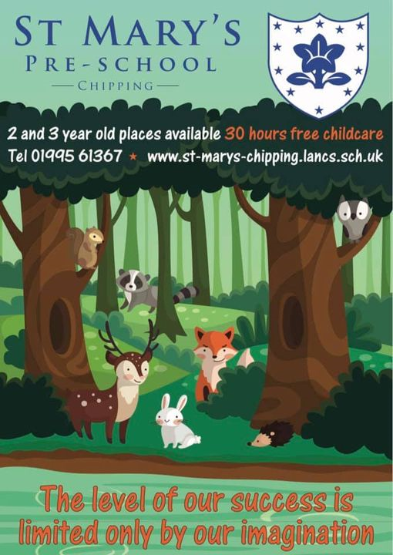  Roald Dahl Day  We had a super Roald Dahl Day on Friday 18th September. The children looked fantastic dressed up as the various characters from all his amazing books. Thankyou for all your support with this – it really does help to bring alive the stories.  Our successful pre-school has been opened for the past two years for three-year olds and now we open our doors to two-year olds from this week. If you know of anyone who may be interested, please ask them to ring the school office on 01995 61367. We gained a Lancashire County Council Early Years Quality Award earlier this year after successfully completing a lengthy and rigorous whole team reflection across eight ‘steps’, which has had a positive impact on our setting. We are extremely proud of what we are able to provide for our children and it is all child centred and led.  Also, a big thank you to Mr Cowburn (Isla’s Daddy) for doing all our graphic design work for our posters and banners – they look amazing. We appreciate your help and support very much. | christmas plans  We do have plans in place to celebrate Christmas in a socially distanced way! More will be revealed in future newsletters. However, can we thank the PTFA – Friends of St. Mary’s, for agreeing to pay for a pantomime group to visit school on the 14th December to perform a Christmas show (3 times!) for our children. It is something to look forward to – especially as we cannot visit the theater this year. We are also looking into other visits and special occasions.  FRIENDS OF ST MARY’S  Finally, our PTFA – Friends of St. Mary’s, are looking for more parents to join. Over the years, they have done an amazing job raising funds for our children in school. They have helped out with the school bus, with the playground, with trips and many other things. If you are interested in joining, please let us know at school and we will pass your interest on to the group. Everyone is welcome – the more the merrier.  Stars of the Week  Friday 9th October  Harry  Blaydon  Sophia  Friday 16th October  Ellie  Isla  Daisy M

