St. Mary’s Primary and Pre-school Newsletter (6) | 16th November 2020 – published every two weeks
Thankyou  Thank you for your continued support during this difficult time. The children have been super positive and are working really hard despite it being a strange time. Please can we remind you that school starts at 8.55am and children should be here ready for the register. Also, can we remind parents to not gather at the school gates when dropping off and picking up. We are working really hard to keep everyone in school as much as possible so appreciate so this would really help.  Anti- bullying Week  November 16th sees the beginning of National Anti-bullying Week. The theme this year is  ‘United Against Bullying.’  We will be discussing this in school during the week and doing workshops on it. Please talk to your child about this very important issue.  We will also discussing the very serious issue of online bullying and appropriate use of the internet and social networking. | School Christmas video  We are hoping to film our Christmas video on either Thursday 19th November or Friday 20th November. Pre-school and reception children are performing a short nativity and years 1/2/3 and 4/5/6 will be performing Christmas carols and songs in their ‘bubbles’ An order from has been sent home already for you to order DVDs or flash drives. Children in years 1 – 6 will need a Christmas jumper / accessories for these two days. They may come to school in them for both days as we don’t know how the filming is going to go and we may need the two days. Finally, a letter is coming home today that gives us permission form you to film the children. Please can you send back to school asap.  REPORTS  Reports will be sent home on Friday 27th November. They will have an overview of progress made in reading, writing and maths and a generic curriculum overview. There will also be some targets for the next term. Please contact us if you have any questions or worries that cannot be met through a report and we will be more than happy to organise a zoom meeting.
What’s Happening? | 16th November 2020 – published every two weeks
bikeability  The children in years 4,5 and 6 have been invited to take part in the LCC approved bike safety programme, Bikeability. The day long course teaches the children the basics of how to ride safely on the road. It is a programme that we have taken part in for many years now with very successful outcomes. Miss Cookson will be sending home permission slips and information.  The children will need to bring their bikes into school for the day. The course will be run on Monday, 30th November.  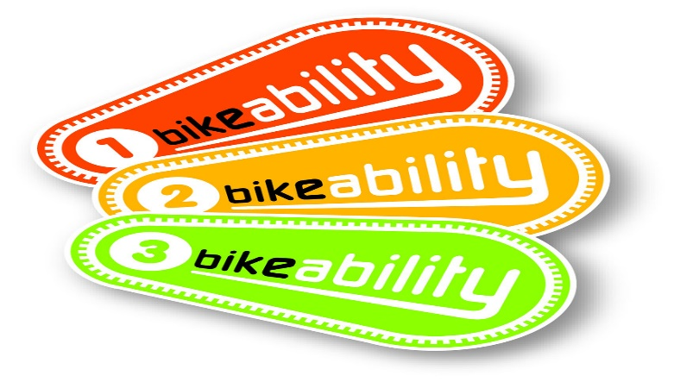 | christmas plans  We have plans in place to celebrate Christmas in a socially distanced way! More will be revealed in future newsletters. However, can we thank the PTFA – Friends of St. Mary’s, for agreeing to pay for a pantomime group to visit school on the 14th December to perform a Christmas show (3 times!) for our children. It is something to look forward to – especially as we cannot visit the theater this year. We are also looking into other visits and special occasions.  FRIENDS OF ST MARY’S  Finally, our PTFA – Friends of St. Mary’s, are looking for more parents to join. Over the years, they have done an amazing job raising funds for our children in school. They have helped out with the school bus, with the playground, with trips and many other things. A letter from the ‘Friends’ will be coming home this week for you to read. Please do consider joining this very valuable team who work hard to support all our children.  Stars of the Week  Friday 13th November  Mia  Arthur  Ella

