St. Mary’s Primary and Pre-school Newsletter (2) | 14th September 2020 – published every two weeks
Welcome back to school  We have had two excellent weeks back in school and the children have all been working really hard in class with lots of enthusiasm – well done everyone!  Please can we remind you that school begins at 8.55am so please be here on time for registration.  Roald Dahl Day  We will be having our annual ‘Roald Dahl Day’ on Friday, 18th September. This is where we ask all our children from pre-school up to year 6 to come to school dressed up as a character from one of his books. During the day, we will be working on literacy-based activities. We are very excited to see all the amazing costumes. Photos will be going on our Facebook page.  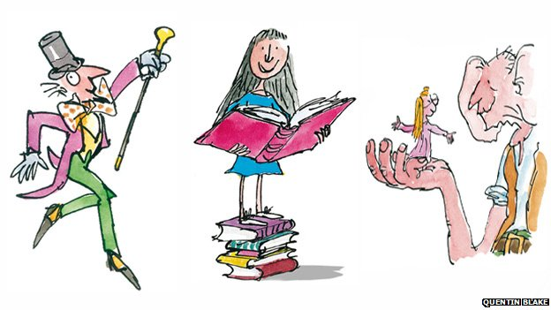 | Nativity  We are planning on having our nativity play at Christmas for all our children in school as usual. For new parents to St. Mary’s, the younger children usually take the main roles whilst the older children support by singing and reading. Obviously, at the moment, we don’t think that we will be able to invite you into school to watch unless things change dramatically. However, we are planning to get it professionally videoed so that you can buy a copy to keep and watch at home. If you know anyone that could do this for us, please would you let us know.  The Life Bus team will be joining us again this Thursday, 17th September. The Life Bus is a PSHE (personal, social and health education) Instead of the children going onto the bus, the teachers will be coming into our classrooms. The programme will cover ‘It’s good to be me’ ‘All about me’ and ‘Feelings.’ There will be bendy pencils for £1.00 for the children to buy if they would like one.
What’s Happening? | 14th September 2020 – published every two weeks
Piano lessons  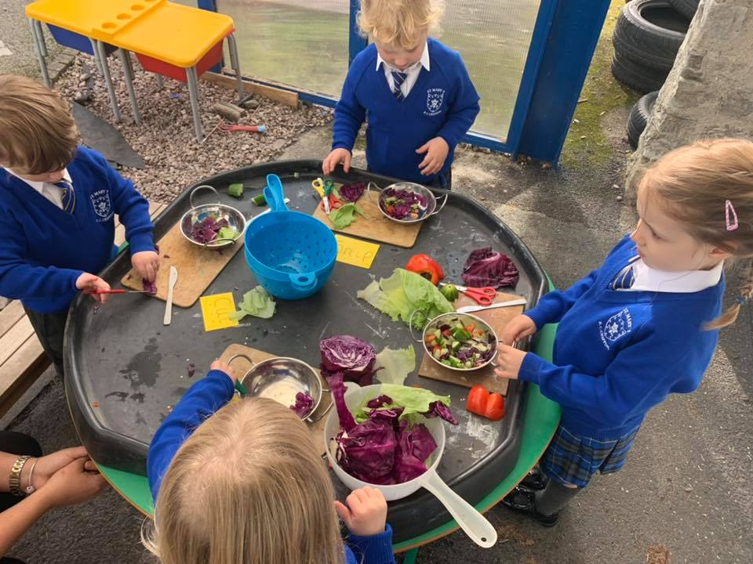  Mr. Hawks, our amazing piano tutor will be beginning his 20 mins piano lessons again in school this Tuesday, 15th September. He will be teaching in a socially distanced manner and will be cleaning the keyboard after every child has finished. The children will be asked to wash their hands before they begin their lessons and after the lesson. If your child is interested in having lessons, please let us know and we will pass your details onto Mr. Hawks who will contact you with more information.  Breakfast and After-School Clubs  Breakfast is from 7.30am, Monday – Friday and the after-school clubs are until 4.15pm, Monday to Thursday. Please call the school office if you would like your child to join them. | Open Days  We are inviting new families to come and visit our school from Monday 12th October until Thursday 22nd October from 4.30pm until 6pm. This will be by appointment only so that we can ensure the safety of all visiting. Please can you share this with any families that you know that have young children and are looking for school places. The poster is also on our Facebook page so again, please do share it. We have already starting taking bookings over the phone for visits – our telephone number is 01995 61367.  Stars of the Week  Friday 4th September  Archie McKenna  Daisy-May Rowlinson  Daniel Donegan  Friday 11th September  Anna Gunn  Tori Gardner  Freddie Bonner  Well done to ALL our children for working hard and trying their best. We have trophies to hand out at the end of the half term to the child from each year group who has really tried hard in everything. Good luck to everyone!

