St. Mary’s Primary and Pre-school Newsletter (1) | 2nd September 2020 – published every two weeks
Welcome back to school  Welcome back to all our children and families. We are so pleased to be back in school after the summer holidays and we are looking forward to catching up on all the time we have missed in school. We especially welcome our new pre-school children, the reception children and Blayden who will be joining year 3. We hope they all settle in quickly and we know that all our children, parents and staff will do everything they can to help them feel part of our family.  Fantastic News!!  Miss Kelsall has successfully finished her teaching assistant apprenticeship with St. Mary’s and has now decided to go on to do her teacher training. After applying to Lancaster University, she has been accepted and will begin her course soon. In the meantime, she will be with us until October half term.  Well done Miss Kelsall – we are all so proud of you! | Apprentices  We are really pleased to report that we have appointed two fantastic teaching assistant apprentices. Miss Jones will be working in years 1/2/3 and Miss Burns will be working in the Early Year’s classroom. They both bring a wealth of experience from their previous roles and studies and we are all looking forward to working with them. Again, we know you make them feel welcome to our school community.  The Life Bus team will be joining us again on Thursday, 17th September. The Life Bus is a PSHE (personal, social and health education) Instead of the children going onto the bus, the teachers will be coming into our classrooms. The programme will cover ‘It’s good to be me’ ‘All about me’ and ‘Feelings.’ There will be bendy pencils for £1.00 for the children to buy if they would like one.  We will be having our annual ‘Roald Dahl Day’ on Friday, 18th September. This is where we ask all our children to come to school dressed up as a character from one of his books. During the day, we will be working on literacy-based activities. Keep an eye out for the photos on our Facebook page!
What’s Happening? | 2nd September 2020 – published every two weeks
Piano lessons  Mr. Hawks, our amazing piano tutor will be beginning his 20 mins piano lessons again in school on Tuesday, 15th September. He will be teaching in a socially distanced manner and will be cleaning the keyboard after every child has finished. The children will be asked to wash their hands before they begin their lessons and after the lesson. If your child is interested in having lessons, please let us know and we will pass your details onto Mr. Hawks who will contact you with more information.  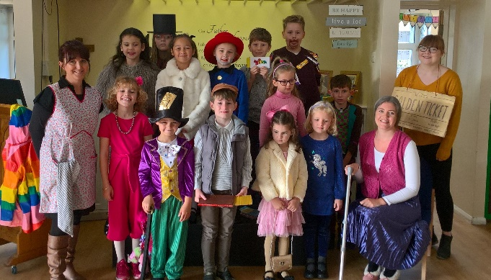  Roald Dahl Day last year  Charlie and the Chocolate Factory  Breakfast and After-School Clubs  All our clubs begin this week. Breakfast is from 7.30am, Monday – Friday and the after-school clubs are until 4.15pm, Monday to Thursday. | School dinners  Tracy, from the Post Office will be making our school dinners from now on. We would however, like to thank Kathy from the Café for all her years of making our school dinners and we wish her all the very best in her new venture. Tracy will be making all her meals from scratch and will hopefully be able to use some of the veg and fruit from our garden that our superb community gardeners have been growing and nurturing over the past few months. We hope that the children will get involved in helping out in the garden too – it’s all very exciting!  PE and Swimming Lessons  PE lessons will begin next week. Please can you send in your child’s labelled kit for next Monday. The children can have either plimsolls or trainers. We will try to do PE outside where possible so as it gets colder, they may need some navy blue / black track suit bottoms to keep warm.  We will let you know when swimming lessons will begin again.  Star of the Week  Every Friday afternoon, we will be holding our ‘celebration assembly.’ One child from each class will be awarded the ‘Star of the Week’ for something that they have achieved be it academic or a kind deed. We can’t wait to see who is going to be trying their hardest over the next few weeks.

