St. Mary’s Primary and Pre-school Newsletter (3) | 28th September 2020 – published every two weeks
House Rental in chipping  We have been approached by a lady who is currently living in Spain with her Granddaughter. She would like to live in Chipping with her granddaughter and start afresh after her husband suddenly passed away in August. If you know of anything, please could you contact us. Thankyou.  Mini Sports Skills  Children across school will be taking part in Preston’s Small School Sporting Championship next week in school. It will be organised IN school in our bubbles and will be judged on time trials.  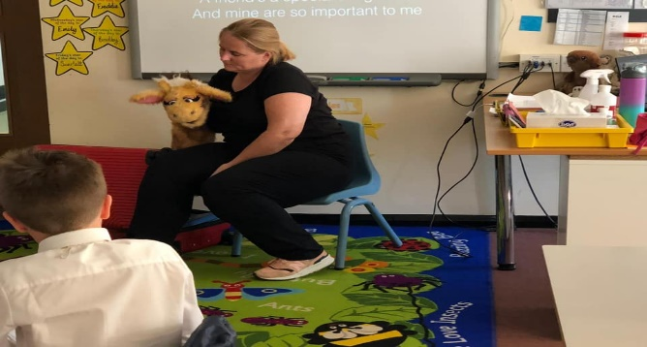  Dean Brandwood who has organsied this will visit school to officiate (socially distancing of course!) and will record our scores. More to follow ….. | School Photos  Tempest Photography will be in school next week to take individual and family group photos. This will be on Tuesday, 6th October. Please can you ensure that your child has their school jumper and tie on this day please. Unfortunately, we cannot invite younger siblings into school this year.  BE SEEN IN GREEN  Our charity ambassador, Sophie, is organising a ‘Be Seen In Green’ day for the Royal Manchester Children’s Hospital on Friday. 9th Oct. The children can come to school wearing green clothes with a donation if they would like to take part. Sophie will collect this and send off to the very deserving charity.  LIFE EDUCATION BUS  Katie and Harold, from the Life Education Bus came to visit us on Thursday, 17th September. We were her first school to visit after the lock down and she was extremely nervous. However, she told us that she loves coming to St. Mary’s because the children and staff are so friendly and warm and that we made her feel very welcome. Thanks Katie – we love you coming to see us!
What’s Happening? | 28th September 2020 – published every two weeks
Roald Dahl Day  We had a super Roald Dahl Day on Friday 18th September. The children looked fantastic dressed up as the various characters from all his amazing books. Thankyou for all your support with this – it really does help to bring alive the stories.  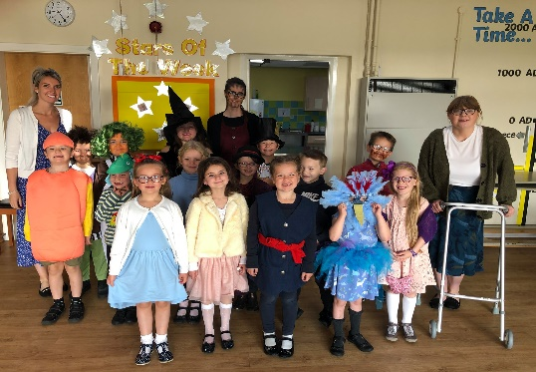  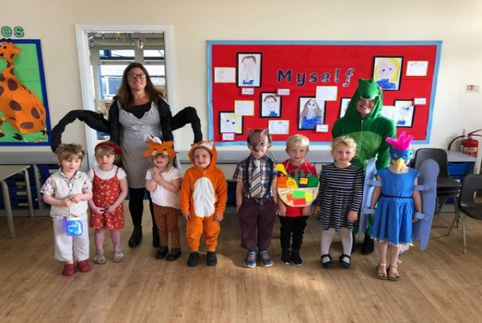  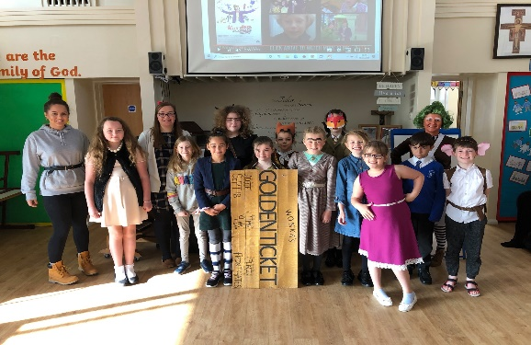 | Open Days  We are inviting new families to come and visit our school from Monday 12th October until Thursday 22nd October from 4.30pm until 6pm. This will be by appointment only so that we can ensure the safety of all visiting. Please can you share this with any families that you know that have young children and are looking for school places. The poster is also on our Facebook page so again, please do share it. We have already starting taking bookings over the phone for visits – our telephone number is 01995 61367.  Stars of the Week  Friday 18th September  Lillie  Arthur  Ollie  Friday 25th September  Harvey  Ave  Barnaby  Well done to ALL our children for working hard and trying their best. We have trophies to hand out at the end of the half term to the child from each year group who has really tried hard in everything. Good luck to everyone!

