Marking and Feedback Statement
2026–27
Rooted in Love. Faith in Action. Learning to Thrive.

Our approach
At St Mary’s, feedback is an important part of Great Teaching. Its purpose is simple: to help children learn, address misconceptions and know what to do next.
We believe effective feedback should be meaningful, manageable and motivating. It does not need to mean lengthy written comments in every book. The most effective feedback is often given in the moment, while learning is taking place, so that pupils can respond immediately.
Our approach is underpinned by our Great Teaching principles: Clear Teaching • Active Participation • Growing Independence.
LIVE MARKING & FEEDBACK
Circulate while pupils work. Notice, question, prompt and correct. Celebrate success. Address misconceptions in the moment. Feedback happens while learning.

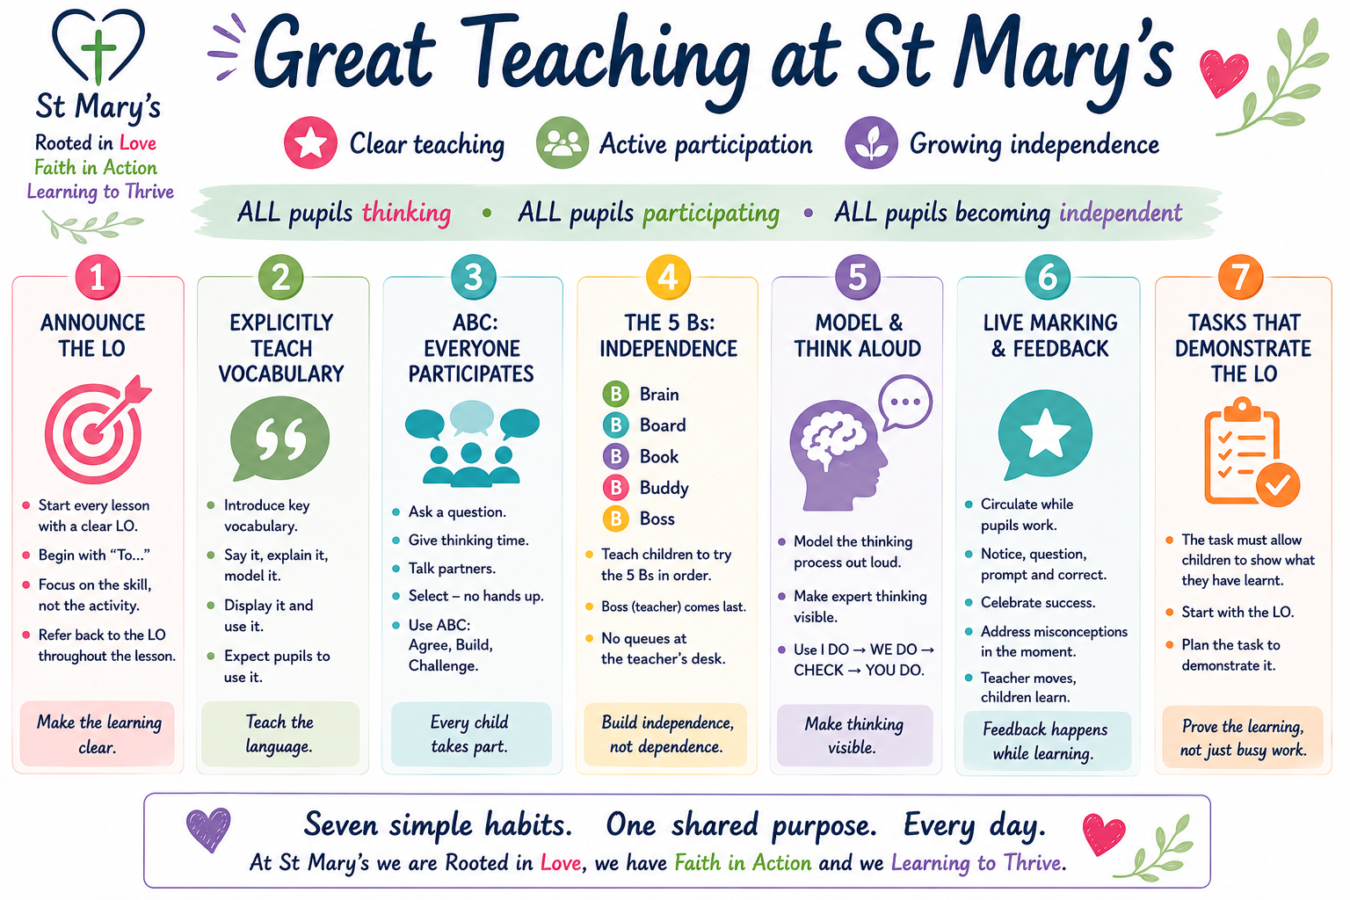

Our principles

Meaningful
Feedback should have a clear purpose and make a difference to learning. Teachers use their professional judgement to decide the most appropriate form of feedback according to the child, subject, task and learning objective. Feedback may be verbal, written, whole-class, individual, peer or self-assessment. There is no expectation that every piece of work will contain a written comment.

Manageable
Feedback should be proportionate and sustainable for both pupils and staff. We do not expect teachers to spend significant amounts of time writing comments that could be communicated more effectively through a conversation, prompt, question or subsequent teaching. Consistency at St Mary’s means consistently high expectations and effective feedback, rather than identical marking in every book or subject.

Motivating
Feedback should help pupils recognise success and understand how to improve. It should encourage pupils to think, respond and become increasingly independent rather than relying on an adult to correct their work for them.
• What have I done well?
• What do I need to do next to improve?

What marking and feedback looks like at St Mary’s

Live feedback first
Wherever possible, feedback should take place during the lesson. Teachers and teaching assistants circulate while pupils work and:
NOTICE → QUESTION → PROMPT → CORRECT → CELEBRATE
Where a misconception is identified, adults respond appropriately. This may include an individual prompt or question, directing a pupil back to a model, vocabulary or previous learning, providing further modelling, bringing a small group together, pausing the class to address a common misconception, or adapting subsequent teaching.
This is an important part of adaptive teaching: assessment and feedback inform what the teacher does next.

Pupils act on feedback
Feedback has little value if nothing happens as a result. Where a pupil is given feedback requiring an improvement or correction, they should normally have the opportunity to respond there and then, or at the earliest appropriate opportunity. We want children to become increasingly able to notice, correct and improve their own work.

Simple marking conventions
Teacher/TA marking is completed in green pen. The following simple conventions may be used where they add value:
✓ | Correct / achieved
× | Incorrect / needs revisiting
VF | Verbal feedback given, where recording this is useful
I | Completed independently
S | Significant adult support
Teachers and teaching assistants do not need to mark every correct answer or annotate every interaction where this would add no value. Where feedback has been given live and the pupil has already responded successfully, there is no requirement to write an additional comment.

Writing
Feedback in writing should focus primarily on the learning objective and the aspect of writing currently being taught. Teachers should not attempt to correct every error. Feedback should be selective and appropriate to the pupil’s age, stage and individual needs.
• reinforce successful features;
• address misconceptions;
• improve vocabulary and sentence construction;
• prompt pupils to check spelling, grammar and punctuation;
• model improvements where necessary; and
• encourage pupils to reread, edit and improve their own work.
On completion of a significant independent piece, achievement should be acknowledged and celebrated.

Spelling
Not every spelling error should be corrected. Teachers use their knowledge of the pupil to select spellings that are appropriate and useful to address, particularly previously taught spelling patterns, age-appropriate common exception/high-frequency words, subject-specific vocabulary and words the pupil should reasonably be expected to spell independently.
The purpose is to improve spelling, not cover a piece of work in corrections.

Mathematics and other subjects
Correct responses may be acknowledged with a tick and incorrect responses identified where this supports learning. Where misconceptions are evident, feedback and teaching are more important than the marking symbol. Adults should intervene, question, model or reteach as appropriate and give pupils an opportunity to demonstrate improved understanding.
Feedback in foundation subjects should focus on the intended learning, including appropriate subject knowledge and vocabulary, rather than presentation alone.

Feedback and independence
Our marking and feedback approach supports our Great Teaching commitment to growing independence. Adults should avoid doing for pupils what pupils can increasingly learn to do for themselves. Where appropriate, pupils are encouraged to use our 5Bs before relying on adult support:
Brain → Board → Book → Buddy → Boss
Feedback should help pupils think, check, improve and become more independent.
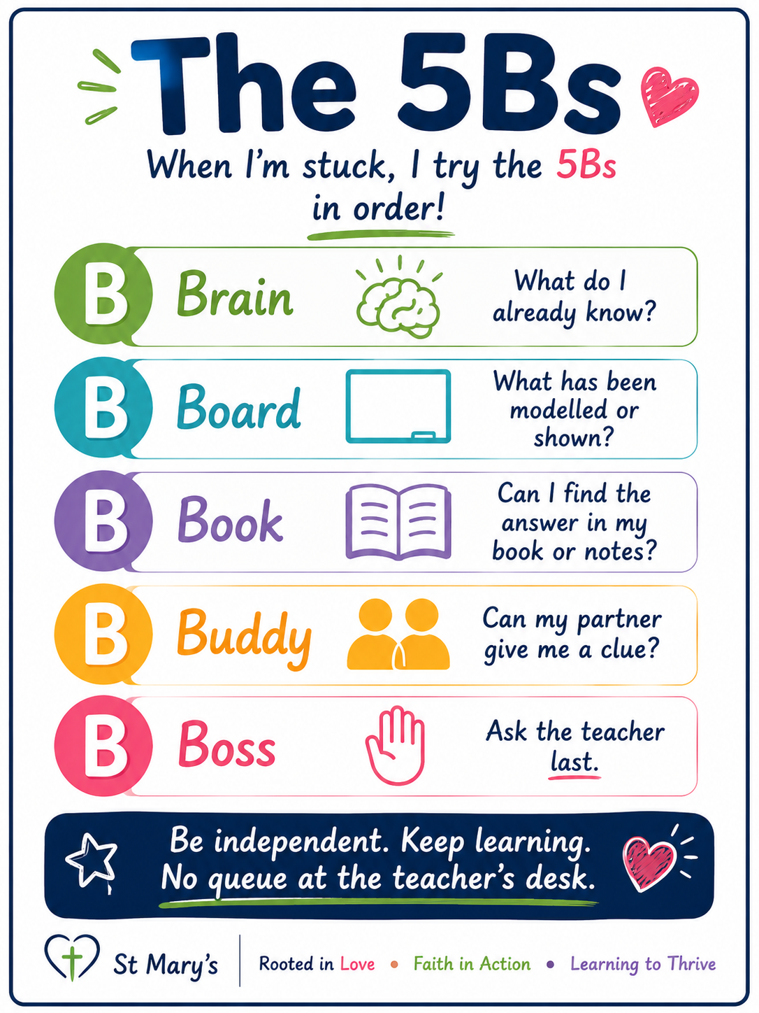

What we do not expect
• every piece of work to have a written teacher comment;
• teachers to write lengthy next steps in every book;
• every spelling or grammatical error to be corrected;
• marking to be completed simply to demonstrate that a teacher has looked at a book;
• every subject to use exactly the same form of feedback; or
• staff to spend time writing feedback that could be communicated more effectively to the pupil verbally.
OUR SHARED EXPECTATION
Feedback happens while learning. We circulate, notice, question, prompt and correct. We celebrate success, address misconceptions and give children opportunities to respond. The impact of feedback matters more than the amount of marking.

Monitoring and review
This statement forms part of our wider Teaching and Learning approach and Great Teaching framework. Its implementation will be supported through professional development, teacher reflection, lesson visits and work scrutiny, with a focus on the impact of feedback on pupils’ learning and independence.
Headteacher: Mrs Katie Jones
Date: September 2026
Review: September 2027

