Mission Statement
At St Mary’s, we are a small school rooted in love, where every child is known, valued and cherished.
We create a safe and nurturing environment where every child feels listened to, respected and able to thrive.
Through high-quality teaching and meaningful learning experiences, we inspire a love of learning that stays with our pupils for life. We support each child to grow in confidence, develop resilience and achieve their full potential.
Guided by our Catholic faith and the example of Mary, we put our faith into action through kindness, service and compassion. We recognise that every child is made in the image of God, and we nurture their unique gifts, helping them to find their voice and make a positive difference in the world.

1. Introduction
At St Mary’s Catholic Primary School, we are committed to providing a high-quality, ambitious and inclusive education for every child.
We believe that great teaching changes lives.
Our approach to teaching and learning is rooted in:
- strong relationships
- high expectations
- evidence-informed practice
- adaptive teaching
- active learning
- inclusion
- curiosity and creativity
- knowing the children in front of us
We want every child to:
- love learning
- feel successful
- develop confidence and independence
- become resilient learners
- think deeply and creatively
- be prepared for the world beyond school
- learn to thrive
Learning at St Mary’s is built upon our school motto:
Rooted in Love • Faith in Action • Learning to Thrive

2. Our Vision for Teaching and Learning
At St Mary’s, relationships are at the heart of learning.
Children learn best when they:
- feel safe
- feel known and valued
- feel emotionally secure
- are actively involved in learning
- experience success
- are appropriately challenged
- are inspired and engaged
We believe:
- every child can succeed
- every child deserves excellent teaching
- inclusion and high expectations go together
- learning should be purposeful and meaningful
- mistakes are valuable opportunities for learning
- adaptive teaching benefits all learners
- children should be active participants, not passive listeners
Teaching should inspire curiosity, independence and a lifelong love of learning.

3. Evidence-Informed Practice
Our teaching and learning approach is informed by educational research and evidence, including:
- Education Endowment Foundation (EEF)
- Rosenshine’s Principles of Instruction
- Cognitive science research
- Metacognition and retrieval practice
- Adaptive teaching and formative assessment research
- SEND in Mainstream Schools guidance
- SSAT research on adaptive teaching and responsive teaching
We are committed to continually reflecting upon and improving our practice through:
- high-quality professional development
- instructional coaching
- collaboration
- research engagement
- lesson study and professional dialogue

4. Adaptive Teaching
At St Mary’s, adaptive teaching is at the heart of excellent classroom practice.
We believe that learning should be “open for everyone” and that all children should be able to access ambitious learning through appropriate support, scaffolding and responsive teaching.
Adaptive teaching means:
- teaching the children in front of you
- anticipating barriers and misconceptions
- responding to assessment and feedback in real time
- providing support without lowering expectations
- ensuring all children can participate successfully
We understand adaptive teaching as:
- proactive adaptation (planning for likely barriers)
- interactive adaptation (responding during lessons)
- retroactive adaptation (reflecting and adapting future teaching)
At St Mary’s:
- no child should feel excluded from learning
- scaffolds are temporary and purposeful
- support should increase independence, not dependence
- children access the same ambitious curriculum through different pathways
We believe:
“Same lesson, different paths.”

5. The EEF “Five-a-Day” Principles
Our classrooms are shaped by the Education Endowment Foundation’s “Five-a-Day” principles for adaptive teaching.
These approaches benefit all learners, particularly pupils with SEND.
1. Explicit Instruction
Teachers:
- give clear explanations
- model learning carefully
- break learning into manageable steps
- check understanding frequently
2. Cognitive and Metacognitive Strategies
Teachers support children to:
- recall prior learning
- think about their learning
- plan, monitor and evaluate strategies
- reflect on success and next steps

3. Scaffolding
Teachers provide:
- sentence stems
- visuals
- worked examples
- practical resources
- chunked instructions
Scaffolds are gradually removed as independence develops.
4. Flexible Grouping
Children may work:
- independently
- in pairs
- collaboratively
- in short-term targeted groups
Grouping remains flexible and responsive to need.
5. Using Technology
Technology may be used to:
- model learning
- support communication
- aid accessibility
- enhance engagement
- support recording and feedback
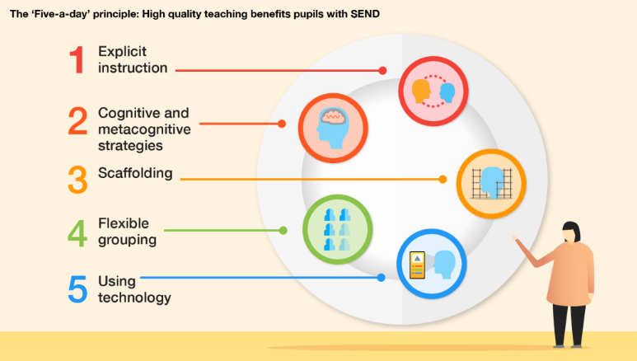

6. Great Teaching at St Mary’s
Alongside the EEF Five-a-Day principles, we have developed a shared framework for Great Teaching at St Mary’s. This brings together our approach to adaptive teaching and identifies seven simple, consistent teaching habits that we expect to see across our school.
Our Great Teaching framework is built around three key principles:
Clear Teaching • Active Participation • Growing Independence
Our shared aim is for all pupils to be thinking, all pupils to be participating and all pupils to be becoming increasingly independent learners.
The seven habits of Great Teaching at St Mary’s are:
1. Announce the Learning Objective (LO)
Every lesson begins with a clear learning objective. The focus is on what pupils are learning rather than simply the activity they are completing. Teachers refer back to the learning objective throughout the lesson so that pupils understand the purpose of their learning and can recognise their progress.
2. Explicitly Teach Vocabulary
Key vocabulary is identified and explicitly taught. Teachers introduce, explain and model new vocabulary, display it where appropriate and expect pupils to use increasingly precise subject-specific language when speaking and writing.
3. ABC – Everyone Participates
We aim for every child to think and participate. Teachers use questioning strategically, provide appropriate thinking time and use talk partners before selecting pupils to respond rather than relying solely on hands-up questioning. Pupils are encouraged to Agree, Build or Challenge (ABC) responses so that classroom talk develops understanding and reasoning.
4. The 5Bs – Developing Independence
We explicitly teach pupils strategies for becoming independent learners. When pupils are unsure or become stuck, they are encouraged to use the 5Bs in order:
Brain → Board → Book → Buddy → Boss
Children first think about what they already know, use available classroom resources and previous learning, seek appropriate support from a peer and approach the teacher when further support is needed. This helps pupils to develop resilience, resourcefulness and independence rather than becoming dependent on adult support.
5. Model and Think Aloud
Teachers make expert thinking visible. They explicitly model both the process and the thinking involved in successful learning, using approaches such as I DO → WE DO → CHECK → YOU DO. Worked examples, demonstrations and teacher think-alouds help pupils understand not only what to do but how and why.
6. Live Marking and Feedback
Feedback happens while learning is taking place. Teachers circulate, observe pupils' work, question, prompt and intervene where appropriate. Success is recognised and misconceptions are identified and addressed at the point of learning. Feedback should enable pupils to improve and move their learning forward.
7. Tasks that Demonstrate the Learning Objective
Tasks are selected because they enable pupils to practise, apply and demonstrate the intended learning. Teachers begin with the learning objective and plan purposeful tasks that provide meaningful evidence of what pupils know, understand and can do. We avoid activity for activity's sake: the task should prove the learning, not simply keep pupils busy.
These seven habits provide a common language for teaching and learning across St Mary’s. They are not intended to create identical lessons or a checklist that must be followed mechanically. Teachers use their professional judgement to apply them responsively according to the subject, learning, age and needs of the pupils.
The Great Teaching framework supports our commitment to adaptive teaching. Through clear explanations, explicit modelling, careful questioning, active participation, responsive feedback and purposeful scaffolding, teachers continually assess pupils' understanding and adapt teaching while maintaining ambitious expectations for all.
Our Great Teaching framework also informs professional development, coaching, teacher reflection and lesson visits. Monitoring focuses on the impact of teaching on pupils: whether they understand the learning, are thinking and participating, receive the support and challenge they need, and are developing the confidence and independence to succeed.
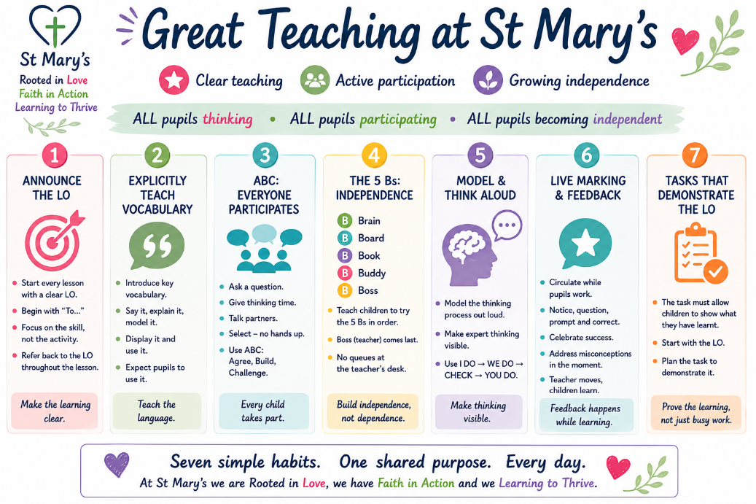
Seven simple habits. One shared purpose. Every day.

7. Relationships at the Heart
At St Mary’s, relationships come first.
We know that children learn best when adults:
- know them well
- understand their strengths and barriers
- listen carefully
- build trust
- show warmth and consistency
- maintain high expectations with compassion
Teachers create classrooms where children:
- feel emotionally safe
- are encouraged to take risks
- are comfortable making mistakes
- learn collaboratively
- feel proud of their achievements
We recognise that emotional wellbeing and learning are closely linked.

8. Active Learning
At St Mary’s, children are active participants in learning.
We aim to reduce passive listening and increase:
- thinking
- discussing
- questioning
- exploring
- rehearsing
- investigating
- creating
- explaining
Learning experiences may include:
- partner talk
- group discussion
- enquiry-based learning
- practical exploration
- outdoor learning
- retrieval practice
- oral rehearsal
- collaborative problem solving
Children should regularly:
- explain their thinking
- justify opinions
- ask questions
- reflect on learning
- learn from mistakes
- work independently and collaboratively

9. Planning for Learning
Effective teaching begins with careful planning.
Planning should:
- start with clear learning intentions
- identify success criteria
- consider prior learning
- anticipate misconceptions
- identify barriers and adaptations
- include opportunities for active learning
- promote vocabulary development
- include opportunities for retrieval and reflection
Teachers are expected to:
- know the children in front of them
- adapt teaching responsively
- plan ambitious learning for all
- ensure learning has purpose and relevance
Learning should be:
- meaningful
- engaging
- ambitious
- inclusive
- purposeful

10. Vocabulary and Communication
Vocabulary is central to learning.
At St Mary’s, teachers explicitly teach and model vocabulary across the curriculum.
Children are supported to:
- understand new vocabulary
- use precise language
- discuss learning confidently
- rehearse language orally
- explain thinking clearly
Strategies may include:
- vocabulary displays
- sentence stems
- semantic mapping
- oral rehearsal
- modelled talk
- retrieval practice
We recognise that strong communication skills support learning, confidence and inclusion.

11. Feedback and Assessment
Assessment is an integral part of effective teaching.
Teachers use:
- formative assessment
- questioning
- retrieval practice
- observations
- discussion
- mini-whiteboards
- live marking and feedback
Assessment helps teachers:
- identify misconceptions
- adapt teaching
- provide support
- deepen understanding
- move learning forward
Feedback should:
- be timely
- be meaningful
- move learning forward
- encourage reflection and improvement

Children are encouraged to:
- reflect on their learning
- edit and improve work
- respond to feedback
- become increasingly independent learners

12. Inclusion and SEND
At St Mary’s, inclusion is everyone’s responsibility.
We are committed to ensuring all children can:
- access the curriculum
- participate fully
- experience success
- feel included and valued
Adaptive teaching is our first response to supporting additional needs.
All teachers are teachers of SEND.
Teaching reflects the EEF guidance that high-quality teaching benefits all pupils, including those with SEND.
Teachers and support staff use:
- scaffolding
- explicit instruction
- flexible grouping
- visual supports
- adaptive resources
- technology
- metacognitive approaches
Support is:
- responsive
- flexible
- evidence-informed
- carefully matched to need

13. Outdoor Learning and the Wider Environment
At St Mary’s, we are fortunate to have a beautiful environment and outdoor space.
We believe learning should extend beyond the classroom wherever possible.
Outdoor learning supports:
- wellbeing
- curiosity
- creativity
- collaboration
- communication
- physical development
- connection with the world around us
Children may learn through:
- forest and nature activities
- outdoor investigation
- practical science
- environmental learning
- active exploration
- outdoor worship and reflection
We want children to appreciate:
- the beauty of creation
- their responsibility to care for the world
- the joy of learning outdoors

14. High Expectations and Classroom Culture
At St Mary’s:
- every child is expected to think deeply
- every child is expected to participate
- every child deserves challenge
- every child deserves support
We promote classrooms where:
- mistakes are celebrated as part of learning
- resilience is developed
- curiosity is encouraged
- effort is recognised
- children feel safe to take risks
Adults model:
- positivity
- curiosity
- professionalism
- kindness
- reflective practice

15. Professional Development
We believe that the quality of education cannot exceed the quality of teaching.
We are committed to high-quality professional development for all staff.
Professional development may include:
- instructional coaching
- peer observations
- research engagement
- consultant support
- subject specialist training
- SEND training
- safeguarding training
- external courses and networks
We work collaboratively with:
- consultants
- subject specialists
- Local Authority advisors
- external agencies
- other schools and partnerships
Professional learning is ongoing and reflective.

16. Monitoring and Evaluation
Teaching and learning are monitored through:
- lesson visits
- learning walks
- pupil voice
- book scrutiny
- planning reviews
- assessment information
- professional dialogue
Monitoring is supportive and developmental.
Its purpose is to:
- improve outcomes for children
- ensure consistency
- identify strengths
- provide support and coaching
- develop excellent practice

17. Roles and Responsibilities
Teachers
Teachers are responsible for:
- delivering high-quality teaching
- adapting learning effectively
- maintaining high expectations
- building positive relationships
- assessing learning responsively
- promoting inclusion
Teaching Assistants
Teaching assistants:
- support learning effectively
- promote independence
- use adaptive strategies
- work collaboratively with teachers
- contribute positively to pupil progress
Subject Leaders
Subject leaders:
- monitor curriculum quality
- support colleagues
- develop subject expertise
- promote high standards
Senior Leaders
Senior leaders:
- monitor teaching and learning
- support professional development
- ensure consistency and inclusion
- drive school improvement
Governors
Governors:
- monitor the quality of education
- support school improvement priorities
- ensure statutory responsibilities are met

18. Linked Guidance
This policy is informed by:
- Education Endowment Foundation guidance
- SEND in Mainstream Schools Guidance
- SSAT Adaptive Teaching Guidance
- Rosenshine’s Principles of Instruction
- Ofsted Education Inspection Framework
- National Curriculum

Approved by: Governing Board
Date: September 2026
Review Date: September 2027

