Relationships and Behaviour Policy
Rooted in Love • Faith in Action • Learning to Thrive
Policy owner | Headteacher
Approved by | Governing Body
Approval date
Review date | July 2027, or earlier following statutory change
Applies to | All pupils, staff, volunteers and visitors

Our central belief
Behaviour is taught, not caught. We combine high expectations with calm, consistent and compassionate support so that every child can feel safe, belong and succeed.

This policy incorporates the Department for Education’s Restrictive interventions, including use of reasonable force, in schools guidance, effective from 1 April 2026.

1. Mission and introduction
At St Mary’s, we are a small school rooted in love, where every child is known, valued and cherished.
We create a safe and nurturing environment where every child feels listened to, respected and able to thrive. Guided by our Catholic faith and the example of Mary, we put faith into action through kindness, service and compassion. We recognise that every child is made in the image of God and nurture each child’s unique gifts.
Positive relationships are at the heart of successful behaviour, learning and wellbeing. We believe that behaviour is part of learning and should be explicitly taught, modelled, practised, recognised and revisited. Our approach is relational, restorative, inclusive and evidence-informed.

2. Scope and linked policies
This policy applies to all pupils during the school day, on educational visits, while travelling to and from school where the school may lawfully regulate conduct, and whenever pupils are representing St Mary’s. It also sets expectations for staff, volunteers and visitors.
It should be read alongside:
- Safeguarding and Child Protection Policy
- SEND Policy and SEND Information Report
- Anti-Bullying Policy
- Online Safety Policy
- Attendance Policy
- Staff Code of Conduct
- Equality Information and Objectives
- Suspension and Permanent Exclusion guidance
- Searching, Screening and Confiscation guidance
- Health and Safety Policy and Complaints Procedure

3. Principles and aims
At St Mary’s, we believe:
- Every child has the right to feel safe, respected, valued and able to learn.
- Positive relationships and a strong sense of belonging support positive behaviour.
- Behaviour is taught, not caught; expectations and routines must be made explicit.
- Behaviour can communicate an unmet need, difficulty or emotion.
- Children benefit from calm, predictable and emotionally available adults.
- Positive behaviour should be noticed, recognised and celebrated.
- Children should be supported to reflect, repair harm and restore relationships.
- Inclusion and high expectations go hand in hand.
- Some pupils require reasonable adjustments, targeted teaching or personalised support.
- Responses must be fair, lawful, proportionate, safeguarding-aware and respectful of dignity.
The aims of this policy are to create a calm and purposeful learning environment; teach self-regulation, resilience and responsibility; establish a consistent whole-school approach; support children who need additional help; and meet statutory duties relating to behaviour, safeguarding, SEND, equality, restrictive interventions and exclusion.

4. Our behaviour curriculum: five rules
Our five rules are rooted in Gospel values and are taught through everyday interactions, lessons, assemblies, collective worship, PSHE, classroom routines and playtimes:
- Be kind – even when it’s hard.
- Be honest – even when no one knows.
- Try your best – even when no one is checking.
- Show respect – to everyone, everywhere.
- Make good choices – even when you’re invisible.
Children are taught what each behaviour looks and sounds like, why it matters, how to practise it and how it supports themselves and others. Expectations are revisited after holidays, at transition points and whenever assessment shows that further teaching is needed.
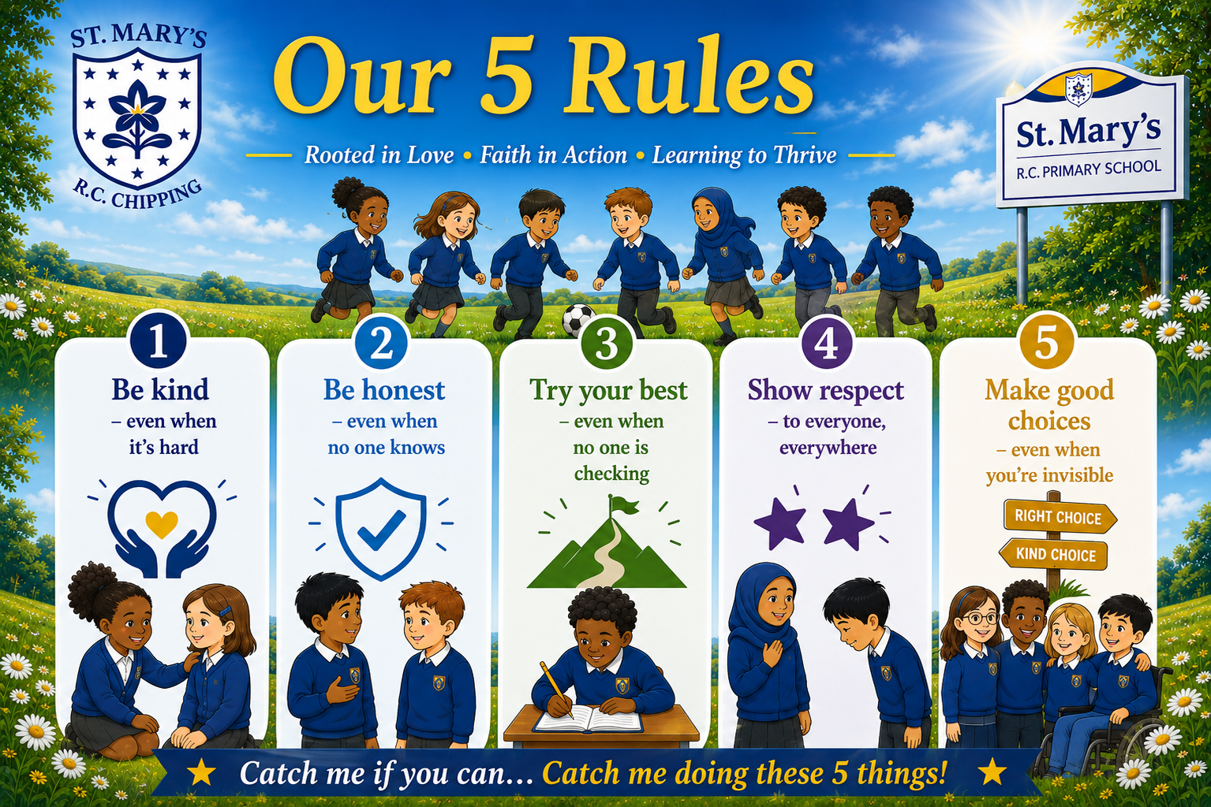

5. Relationships, belonging and adult practice
Children learn best when they feel emotionally safe, connected and valued. Staff build warm, respectful relationships, know pupils well, maintain clear boundaries and communicate with compassion.
All adults will:
- Model kindness, honesty, effort, respect and responsible choices.
- Use calm, respectful and age-appropriate language.
- Teach and maintain predictable routines.
- Apply expectations fairly and consistently while making reasonable adjustments.
- Notice early signs of difficulty and intervene supportively.
- Avoid humiliation, sarcasm, shouting and public confrontation.
- Separate the behaviour from the child and preserve dignity.
- Support co-regulation before expecting reflection or problem-solving.
- Follow through consistently and communicate relevant information to colleagues.

6. Positive recognition: Catch Me If You Can
We aim to catch children following our five rules and reinforce positive behaviours until they become secure habits. Recognition is specific, genuine and focused on effort, character, improvement and positive choices.
- Specific verbal praise
- Catch Me If You Can stickers and certificates
- Celebration assemblies
- Positive telephone calls or messages home
- Sharing achievements with other adults
- Recognition boards or class rewards
- Responsibilities and leadership opportunities

7. Responding to and supporting behaviour
Responses are relational, supportive, restorative and proportionate. Adults seek to notice difficulty early, protect safety, teach better choices and restore relationships.
Stage | Adult response
1. Notice – Praise – Encourage – Build | Notice wanted behaviour; use specific praise; reinforce expectations and build success.
2. Notice – Support – Redirect – Reassure | Approach quietly and privately; offer prompts, reassurance and redirection; reduce anxiety.
3. Stay – Protect – Reduce – Guide | Remain calm and present; prioritise safety; reduce language and demands; guide towards safe alternatives and seek support.
4. Care – Soothe – Reconnect – Reflect | Allow regulation first. When ready, support reflection, repair and a successful return.
5. Ongoing Support | Use targeted provision, reasonable adjustments, behaviour support plans, SEND support or multi-agency advice where needed.
6. Log – Monitor – Review | Record significant incidents on CPOMS; identify patterns; communicate with families; review support.

Restorative reflection
Reflection takes place only when the child is calm and ready. It is private, supportive, age-appropriate and focused on learning rather than shame. Adults may ask:
- Tell me what happened.
- Who has been affected, including you?
- How can we resolve or repair this?
- What could you do differently next time?
- What support do you need?

Serious or persistent incidents
Serious incidents, persistent disruption or behaviour that places anyone at risk may require immediate senior-leader involvement, removal from an activity, communication with parents, a risk assessment, an individual support plan, suspension or—in the most serious circumstances—permanent exclusion. Any response will be lawful, reasonable, fair and proportionate.
Significant behaviour incidents are recorded on CPOMS under the behaviour category. Patterns are reviewed. In line with the school’s operational guide, following three relevant incidents senior leaders will contact parents and speak with the child; a behaviour support plan may then be considered. Professional judgement remains necessary where an incident requires earlier action.

8. Playtimes and lunchtimes
The same expectations apply throughout the school day. Adults support safe and inclusive play through clear routines, active supervision, structured opportunities, positive recognition and restorative conversations. Relevant information is shared promptly with class teachers and senior leaders.

9. SEND, inclusion and reasonable adjustments
St Mary’s is an inclusive school. Behaviour may be affected by communication needs, sensory processing, anxiety, social and emotional needs, trauma, medical needs, neurodiversity or other SEND. We seek to understand barriers while maintaining ambitious and appropriate expectations.
Reasonable adjustments and graduated support may include:
- Adapted language, routines, resources or expectations
- Visual support, movement or sensory breaks
- Alternative regulation strategies and access to a safe space
- A trusted adult and planned key-adult check-ins
- Targeted pastoral, CBT-informed or communication interventions
- Individual behaviour, regulation or risk-management plans
- SENDCo involvement and advice from external professionals
Support plans focus on strengths, relationships, communication, regulation, safety and positive outcomes. Decisions will consider the Equality Act 2010, the SEND Code of Practice and safeguarding duties. Suspension will not be used simply because a pupil has unmet SEND needs or disability-related behaviour.

10. Restrictive Interventions, including Reasonable Force

At St Mary’s, we prioritise positive relationships, prevention, early support, co-regulation and de-escalation. Restrictive intervention is always a last resort.

There may be exceptional circumstances where a member of staff needs to use reasonable force or another restrictive intervention to keep a pupil or others safe. All members of school staff have the legal power to use reasonable force in certain circumstances, including to prevent a pupil from causing injury to themselves or others, committing a criminal offence, damaging property or causing disorder.

Any intervention must be lawful, necessary, proportionate, the least restrictive option reasonably available and used for the shortest possible time. The pupil’s dignity, welfare, individual needs and any SEND or disability must always be considered. Force must never be used as punishment.

Staff will seek to prevent the need for restrictive intervention through calm communication, strong relationships, reasonable adjustments, knowledge of individual pupils, early identification of triggers and appropriate de-escalation strategies.

Significant incidents involving the use of force, and incidents involving seclusion or restraint, will be recorded and reported in accordance with statutory requirements. Parents/carers will be informed in writing as soon as practicable, subject to the limited statutory exceptions. Appropriate support and debriefing will be provided for pupils and staff following an incident.

Full procedures, including definitions, prevention and de-escalation, SEND considerations, staff responsibilities, recording and reporting requirements, post-incident support and governance arrangements, are set out in the school’s Use of Reasonable Force and Restrictive Interventions Policy.

11. Safeguarding and vulnerable pupils
Behaviour and safeguarding are closely linked. A change in behaviour may indicate distress, mental-health difficulty, bullying, neglect, abuse, bereavement, trauma or another safeguarding concern. Staff will follow the Safeguarding and Child Protection Policy and report concerns to the Designated Safeguarding Lead.
Children who are looked after, previously looked after, young carers or experiencing adversity may require additional support and careful consideration of known vulnerabilities.

12. Bullying
Bullying is not tolerated. It is behaviour by an individual or group, repeated over time, that intentionally hurts another individual or group. It may be physical, verbal, emotional, online, discriminatory or prejudice-related. Concerns will be taken seriously, investigated, recorded and addressed under the Anti-Bullying Policy and safeguarding procedures.

13. Suspensions and permanent exclusions
Suspension and permanent exclusion are used only when warranted and in accordance with current statutory guidance. Only the Headteacher may suspend or permanently exclude a pupil.
A decision will be lawful, reasonable, fair and proportionate and will consider safeguarding, SEND and disability, contributing factors, previous support and the impact on the education and welfare of others. Permanent exclusion will be considered only in response to a serious breach or persistent breaches of this policy and where allowing the pupil to remain would seriously harm the education or welfare of the pupil or others.
Parents will be informed without delay and provided with the required information. Reintegration after suspension will be planned carefully to support a successful return.

14. Roles and responsibilities
Role | Core responsibilities
Headteacher | Establish the culture; ensure the policy is implemented; determine serious sanctions and exclusions; oversee restrictive-intervention procedures, training, recording, reporting and review.
All staff | Teach and model expectations; build relationships; respond consistently; make reasonable adjustments; safeguard pupils; record and report concerns and significant incidents.
Pupils | Learn and follow the five rules; treat others with kindness and respect; take increasing responsibility; engage in reflection and repair.
Parents and carers | Work in partnership; share relevant information; support expectations; attend reviews and communicate concerns respectfully.
Governing body | Approve and monitor the policy; review behaviour, suspension and restrictive-intervention information; provide support and challenge; assure statutory compliance.

15. Monitoring, evaluation and review
School leaders monitor behaviour through CPOMS, safeguarding records, pupil and parent voice, staff feedback, attendance, suspension and exclusion information, SEND information and restrictive-intervention records. Governors receive proportionate, anonymised information and consider fairness, consistency, trends and impact.
This policy will be reviewed annually and sooner if legislation, statutory guidance, local-authority advice, school context or evaluation indicates that change is required.

16. Legal and guidance framework
- Education and Inspections Act 2006, including sections 89, 93 and 93A
- Schools (Recording and Reporting of Seclusion and Restraint) (No. 2) (England) Regulations 2025
- Equality Act 2010
- Human Rights Act 1998
- Health and Safety at Work etc. Act 1974
- Children and Families Act 2014 and SEND Code of Practice
- DfE Behaviour in Schools
- DfE Restrictive Interventions, Including Use of Reasonable Force, in Schools (effective 1 April 2026)
- DfE Searching, Screening and Confiscation at School
- DfE Suspension and Permanent Exclusion
- Keeping Children Safe in Education
- EEF Improving Behaviour in Schools

Appendix A: Responding to and Supporting Behaviour
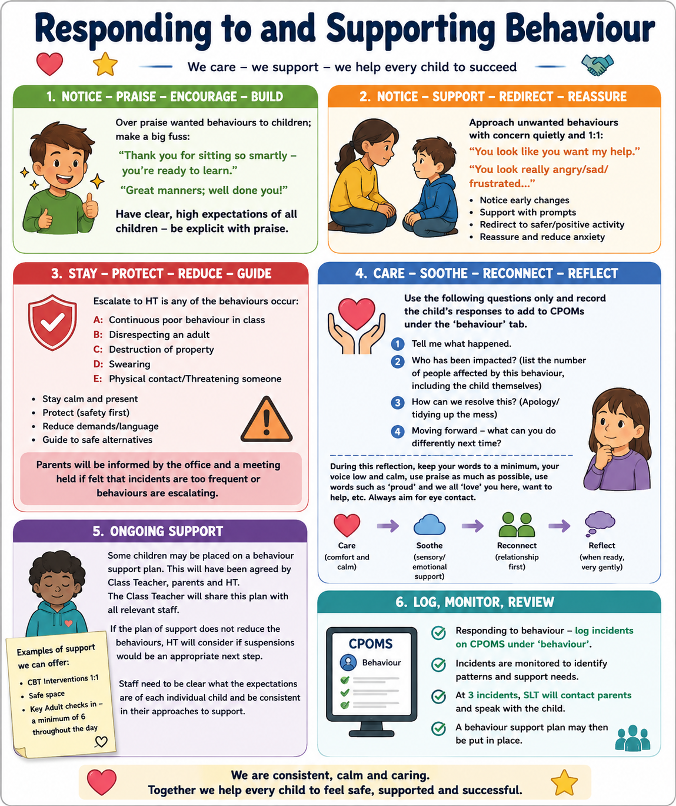

Appendix B: Restorative scripts

Questions
- Tell me what happened.
- What were you feeling?
- Who has been affected, including you?
- How can we put things right?
- What could you do differently next time?
- What support do you need?

Calm adult scripts
- I’m here to help.
- You are safe.
- I can see that you are finding this difficult.
- Let’s solve this together.
- Take the time you need; we will talk when you are ready.
- Thank you for making a safer choice.

Appendix C: Minimum restrictive-intervention record
The school record must enable staff and leaders to evidence:
- Pupil and staff names
- SEND status, medical information and relevant vulnerabilities
- Date, time, location and duration
- Antecedent, context and possible triggers
- Prevention and de-escalation attempted
- Reason intervention was necessary
- Type and degree of force, restraint or seclusion
- How the pupil’s welfare and dignity were considered
- Injuries, medical checks and treatment
- Pupil, staff and witness accounts where appropriate
- Post-incident support and relational repair
- Date, time and method of written parent notification
- Leadership review and actions
- Risk-assessment or support-plan review

Document approval
Approved by
Signature
Date
Next review | July 2027

