Mission Statement
At St Mary’s, we are a small school rooted in love, where every child is known, valued and cherished.
We create a safe and nurturing environment where every child feels listened to, respected and able to thrive.
Through high-quality teaching and meaningful learning experiences, we inspire a love of learning that stays with our pupils for life. We support each child to grow in confidence, develop resilience and achieve their full potential.
Guided by our Catholic faith and the example of Mary, we put our faith into action through kindness, service and compassion. We recognise that every child is made in the image of God, and we nurture their unique gifts, helping them to find their voice and make a positive difference in the world.

1. Introduction
At St Mary’s Catholic Primary School, we are committed to ensuring that every child is known, valued and supported to thrive.
We believe that all children can succeed when teaching is inclusive, relationships are strong and support is carefully matched to need.
Our SEND provision is rooted in:
- inclusion
- high expectations
- strong relationships
- early identification
- adaptive teaching
- collaboration with families
- a whole-child approach
We recognise that children develop and learn in different ways and that some children may require additional support to achieve their full potential academically, socially, emotionally and spiritually.

This policy reflects the SEND Code of Practice (2015) and the Equality Act 2010.
This policy should be read alongside:
- Relationships and Behaviour Policy
- Accessibility Plan
- Equality Policy
- Safeguarding and Child Protection Policy
- Attendance Policy
- Medical Needs Policy

2. Our Vision for SEND
At St Mary’s, we want every child to:
- feel safe, valued and included
- experience success
- develop confidence and independence
- build positive relationships
- access high-quality teaching
- have their strengths recognised
- receive support matched to their needs
- thrive emotionally, socially and academically
We are a highly inclusive school and believe that inclusion is everyone’s responsibility.

3. Our Inclusive Approach
At St Mary’s, high-quality adaptive teaching is at the heart of teaching and learning.
Teachers know their children well and carefully adapt teaching to ensure all pupils can access learning successfully.
We believe that strong universal provision benefits all learners.
This includes:
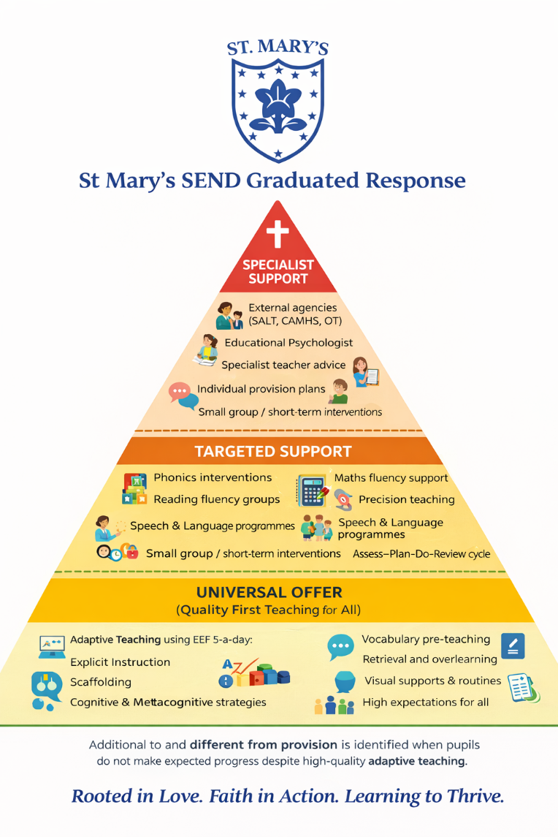
- adaptive teaching
- explicit instruction
- scaffolding and visual support
- flexible grouping
- retrieval practice
- pre-teaching vocabulary
- chunked instructions
- clear routines and expectations
- opportunities for overlearning and repetition
- supportive classroom environments
- emotion coaching and regulation support
Progress is carefully monitored through:
- ongoing teacher assessment
- pupil progress meetings
- formative assessment
- observations
- discussions with pupils and families
Where children are not making expected progress despite high-quality adaptive teaching, further support may be considered.

4. Identifying SEND
At St Mary’s, we recognise the importance of early identification and intervention.
Concerns may be identified through:
- teacher observations
- progress tracking
- pupil progress meetings
- discussions with parents/carers
- pupil voice
- assessments and screening tools
- external agency involvement
We understand that children’s needs may change over time and that identification is an ongoing process.
The four broad areas of need identified within the SEND Code of Practice are:
Communication and Interaction
Including:
- speech and language difficulties
- social communication difficulties
- autism spectrum condition (ASC)
Cognition and Learning
Including:
- moderate learning difficulties
- specific learning difficulties such as dyslexia, dyscalculia or dyspraxia
Social, Emotional and Mental Health (SEMH)
Including:
- anxiety
- emotional regulation difficulties
- attachment difficulties
- ADHD

Sensory and/or Physical Needs
Including:
- hearing impairment
- visual impairment
- sensory processing needs
- physical disabilities

5. Assessing Need – SNAP
At St Mary’s, we use a range of assessment tools to help us build a full picture of each child’s strengths and needs.
One of these tools is SNAP (Special Needs Assessment Profile).
SNAP is an assessment tool which helps school to:
- identify possible barriers to learning
- understand learning strengths and difficulties
- explore emotional wellbeing and relationships
- support early identification of needs
- inform appropriate support and intervention
SNAP allows us to consider the whole child, including:
- learning
- self-esteem
- relationships
- engagement
- communication
- emotional wellbeing
This helps us ensure support is carefully matched to individual needs.

6. The Graduated Approach – Assess, Plan, Do, Review
At St Mary’s, we follow the graduated approach outlined in the SEND Code of Practice.
This follows four stages:
Assess
We gather information about the child’s:
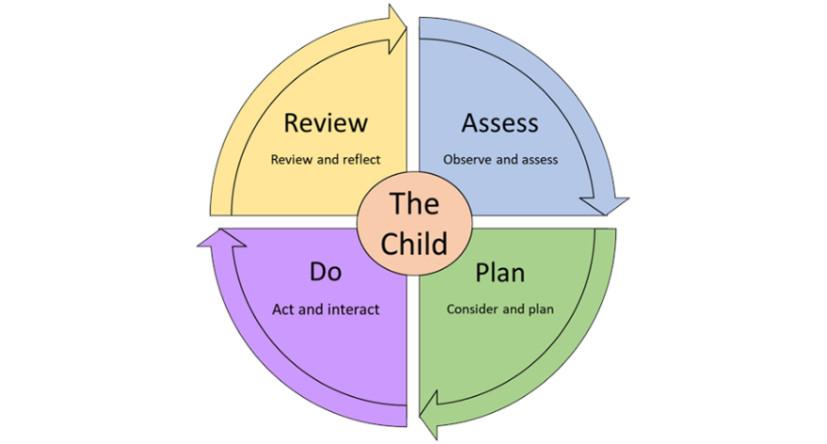
- progress
- strengths
- needs
- wellbeing
- barriers to learning
This may include:
- teacher assessments
- observations
- SNAP assessments
- discussions with parents and pupils
- advice from specialists
Plan
Support and outcomes are agreed collaboratively.
This may include:
- classroom adaptations
- interventions
- pastoral support
- specific targets
- specialist advice
Parents and carers will always be informed and involved in planning support.

Do
Support is delivered through:
- adaptive teaching
- targeted intervention
- pastoral support
- specialist strategies
- individualised provision
Class teachers remain responsible for the progress and wellbeing of all pupils in their class.
Review
Support is reviewed regularly with:
- staff
- parents/carers
- pupils
- specialists where appropriate
We consider:
- progress made
- what is working well
- any ongoing barriers
- next steps
Support is then adapted accordingly.

7. Universal, Targeted and Specialist Support
Universal Support
Every child receives:
- high-quality adaptive teaching
- inclusive classroom practice
- emotional wellbeing support
- clear routines and expectations
- opportunities for success
This is known as our universal offer.
Targeted Support
Some children may require additional short-term support.
This may include:
- phonics interventions
- reading fluency groups
- maths fluency support
- speech and language programmes
- emotional wellbeing support
- social skills groups
- precision teaching
- additional guided practice
Interventions are:
- evidence-informed
- time-limited
- monitored carefully
- reviewed regularly
Specialist Support
Some children may require more personalised or specialist provision.
This may involve:
- Educational Psychologist involvement
- Speech and Language Therapy
- Occupational Therapy
- CAMHS
- specialist teachers
- SEND advisory services
- personalised provision plans
- bespoke adaptations and strategies
External agencies work in partnership with school and families to support the child effectively.

8. Working with Parents and Carers
At St Mary’s, we believe that strong partnerships with families are essential.
Parents and carers know their children best and play a vital role in supporting progress and wellbeing.
We will:
- listen to parents’ views
- communicate regularly
- involve families in decision-making
- share progress and support plans
- work collaboratively and honestly
Parents and carers will always be informed if:
- concerns arise
- additional support is introduced
- specialist referrals are being considered
We encourage parents to speak to:
- class teachers
- the SENDCo
- the Headteacher
if they have any concerns.

9. Pupil Voice
We believe children should be involved in decisions about their learning and support.
Children are encouraged to:
- share their views
- talk about what helps them
- discuss their strengths and challenges
- contribute to reviews and target setting
We want children to feel:
- heard
- respected
- included
- confident

10. Emotional Wellbeing and Relationships
At St Mary’s, relationships are central to our inclusive approach.
We recognise that:
- emotional wellbeing impacts learning
- behaviour can communicate unmet need
- children thrive when they feel safe and connected
We provide:
- nurturing relationships
- emotionally available adults
- calm and consistent routines
- regulation support
- pastoral care
- SEMH support where needed
We work closely with families and outside agencies to support children experiencing emotional or mental health difficulties.

11. Accessibility and Inclusion
St Mary’s is committed to inclusion for all pupils.
We will:
- make reasonable adjustments
- remove barriers to learning
- adapt provision where appropriate
- promote equality of opportunity
- ensure pupils with SEND are included in all aspects of school life
We comply with duties under:
- the Equality Act 2010
- the SEND Code of Practice

12. Education, Health and Care Plans (EHCPs)
Where a child’s needs are significant and require provision beyond the school’s ordinarily available offer, school may request an Education, Health and Care Needs Assessment.
This process is completed in partnership with:
- parents/carers
- external professionals
- the Local Authority
Children with EHCPs will have:
- personalised outcomes
- regular reviews
- carefully planned provision
- close partnership between home and school

13. Monitoring and Review
SEND provision is monitored through:
- pupil progress meetings
- intervention reviews
- observations
- pupil voice
- parent feedback
- SEND reviews
- governor monitoring
The effectiveness of provision is reviewed regularly to ensure children receive the support they need.

14. Roles and Responsibilities
The SENDCo
The SENDCo is responsible for:
- coordinating SEND provision
- supporting staff
- liaising with families
- working with outside agencies
- monitoring progress
- ensuring statutory responsibilities are met
Class Teachers
Class teachers are responsible for:
- high-quality adaptive teaching
- identifying concerns
- implementing support strategies
- monitoring progress
- working closely with families
Governors
Governors are responsible for:
- monitoring SEND provision
- ensuring statutory duties are met
- supporting inclusion across school

15. Linked Guidance
This policy is informed by:
- SEND Code of Practice (2015)
- Equality Act 2010
- Children and Families Act 2014
- NASEN guidance on effective SEND provision
- Keeping Children Safe in Education

Approved by: K Jones
Date: September 2026
Review Date: September 2027

