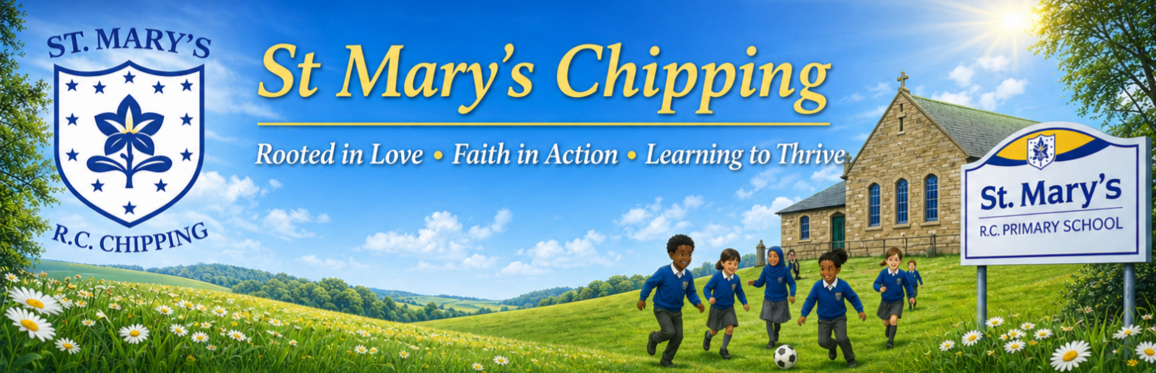

Welcome to our July Newsletter!
As we begin the final two weeks of the school year, we still have so much to celebrate together. This is always a special time for reflection – looking back at the progress our children have made, how much they have grown in confidence and character and all that we have achieved together as a school family.

There are still lots of exciting events to come before we break up for the summer, so please take a few moments to read through this newsletter carefully. It contains important updates and key information about the end of term, as well as plenty of reasons to celebrate another wonderful year at our school.

A message from Mrs Jones

As we come to the end of the year, I would like to say a heartfelt thank you for the warm welcome you have given me since taking up post in January. It has been a genuine privilege to get to know our wonderful children, families and wider school community.
I would also like to thank our incredible staff team, who work tirelessly each and every day to provide the very best opportunities and care for our children. Their dedication, commitment and passion make our school such a special place to learn and grow.
I hope you all have a wonderful, restful summer holiday filled with precious time together. Thank you for your continued support throughout the year. I look forward to welcoming everyone back in September for another exciting year of learning, growth and success.

Attendance
St Mary’s Attendance: 94.61%
National Attendance: 93.26%
Good attendance is essential for children to achieve their best. Even a short absence can have a significant impact on learning – for example, missing one week of school means around 25 hours of learning is lost, which can create gaps in knowledge and affect progress.


📅 Diary Dates for July

8th July Y6 Production of ‘A World Within’
10th July French Day
10th July End of Year Reports
14th July Pre-school/Reception
Trip to Lytham
14th July Water Safety Talk
15th July Leavers’ Assembly
16th July Rock Steady Assembly
ALL Welcome

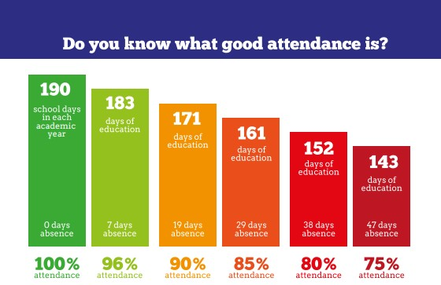

Looking Ahead to September
As we prepare for the new academic year, we are delighted to share some exciting staffing news.
Following Miss Bennett's maternity leave, Mrs Hoskins will be moving into EYFS to provide maternity cover. This has created an opportunity for us to appoint Mrs Hatton, who will join our teaching team to cover Mrs Hoskins' part-time role.
We are also pleased to announce that, following approval from our Governing Body, Miss Bowker will be joining our school as our Year 3/4 teacher. Miss Bowker will teach English and Maths to our Year 3 and 4 children each morning.
These appointments are a really positive step for our growing school. They allow us to keep our class sizes small, maintaining the nurturing, family feel that is so important to us, whilst ensuring we continue to meet the needs of our increasing pupil numbers.
In the afternoons, our classes will be organised as follows:
- Pre-School and Reception will be taught together by Mrs Hutchings and Mrs Hoskins.
- Years 1, 2 and 3 will be taught together by Mrs Jardine.
- Years 4, 5 and 6 will be taught together by Mrs Tallentire.
- PPA will continue to be covered by Miss Haresnape.
We are excited about the opportunities these changes will bring and look forward to another successful year of learning together.

Year 6 Enterprise
As many of you know, our Year 6 children have been busy developing and launching their very own businesses with the support of Adam Graham. Throughout this project, they have learned valuable entrepreneurial skills including teamwork, budgeting, marketing, problem-solving and customer service.
We would love as many families as possible to support their fantastic business ventures. All profits raised will go towards improving our school playground, helping us to provide more inclusive play equipment for all of our children to enjoy.
This Friday (3rd July):
- 🧽 Car Wash: 1:30pm–4:00pm
- 🛍️ Enterprise Stalls: Open throughout the afternoon in the school hall.
As Preschool will be holding their Sports Day, there will be no Friday assembly this week. Instead, families are warmly invited to visit the hall during the afternoon to browse the stalls and support our young entrepreneurs.
The enterprise stalls will also be open after the Year 6 Leavers' Production, following the Leavers' Assembly and on the final day of term, giving everyone plenty of opportunities to support the children.
Please bring cash, as we are unable to accept card payments.
Thank you, as always, for your continued support. We know our Year 6 children will really appreciate it!



