Relationships and Behaviour Policy
Rooted in Love • Faith in Action • Learning to Thrive
Policy owner | Headteacher
Approved by | Governing Body
Approval date
Review date | July 2027, or earlier following statutory change
Applies to | All pupils, staff, volunteers and visitors

Our central belief
Behaviour is taught, not caught. We combine high expectations with calm, consistent and compassionate support so that every child can feel safe, belong and succeed.

This policy incorporates the Department for Education’s Restrictive interventions, including use of reasonable force, in schools guidance, effective from 1 April 2026.

1. Mission and introduction
At St Mary’s, we are a small school rooted in love, where every child is known, valued and cherished.
We create a safe and nurturing environment where every child feels listened to, respected and able to thrive. Guided by our Catholic faith and the example of Mary, we put faith into action through kindness, service and compassion. We recognise that every child is made in the image of God and nurture each child’s unique gifts.
Positive relationships are at the heart of successful behaviour, learning and wellbeing. We believe that behaviour is part of learning and should be explicitly taught, modelled, practised, recognised and revisited. Our approach is relational, restorative, inclusive and evidence-informed.

2. Scope and linked policies
This policy applies to all pupils during the school day, on educational visits, while travelling to and from school where the school may lawfully regulate conduct, and whenever pupils are representing St Mary’s. It also sets expectations for staff, volunteers and visitors.
It should be read alongside:
- Safeguarding and Child Protection Policy
- SEND Policy and SEND Information Report
- Anti-Bullying Policy
- Online Safety Policy
- Attendance Policy
- Staff Code of Conduct
- Equality Information and Objectives
- Suspension and Permanent Exclusion guidance
- Searching, Screening and Confiscation guidance
- Health and Safety Policy and Complaints Procedure

3. Principles and aims
At St Mary’s, we believe:
- Every child has the right to feel safe, respected, valued and able to learn.
- Positive relationships and a strong sense of belonging support positive behaviour.
- Behaviour is taught, not caught; expectations and routines must be made explicit.
- Behaviour can communicate an unmet need, difficulty or emotion.
- Children benefit from calm, predictable and emotionally available adults.
- Positive behaviour should be noticed, recognised and celebrated.
- Children should be supported to reflect, repair harm and restore relationships.
- Inclusion and high expectations go hand in hand.
- Some pupils require reasonable adjustments, targeted teaching or personalised support.
- Responses must be fair, lawful, proportionate, safeguarding-aware and respectful of dignity.
The aims of this policy are to create a calm and purposeful learning environment; teach self-regulation, resilience and responsibility; establish a consistent whole-school approach; support children who need additional help; and meet statutory duties relating to behaviour, safeguarding, SEND, equality, restrictive interventions and exclusion.

4. Our behaviour curriculum: five rules
Our five rules are rooted in Gospel values and are taught through everyday interactions, lessons, assemblies, collective worship, PSHE, classroom routines and playtimes:
- Be kind – even when it’s hard.
- Be honest – even when no one knows.
- Try your best – even when no one is checking.
- Show respect – to everyone, everywhere.
- Make good choices – even when you’re invisible.
Children are taught what each behaviour looks and sounds like, why it matters, how to practise it and how it supports themselves and others. Expectations are revisited after holidays, at transition points and whenever assessment shows that further teaching is needed.
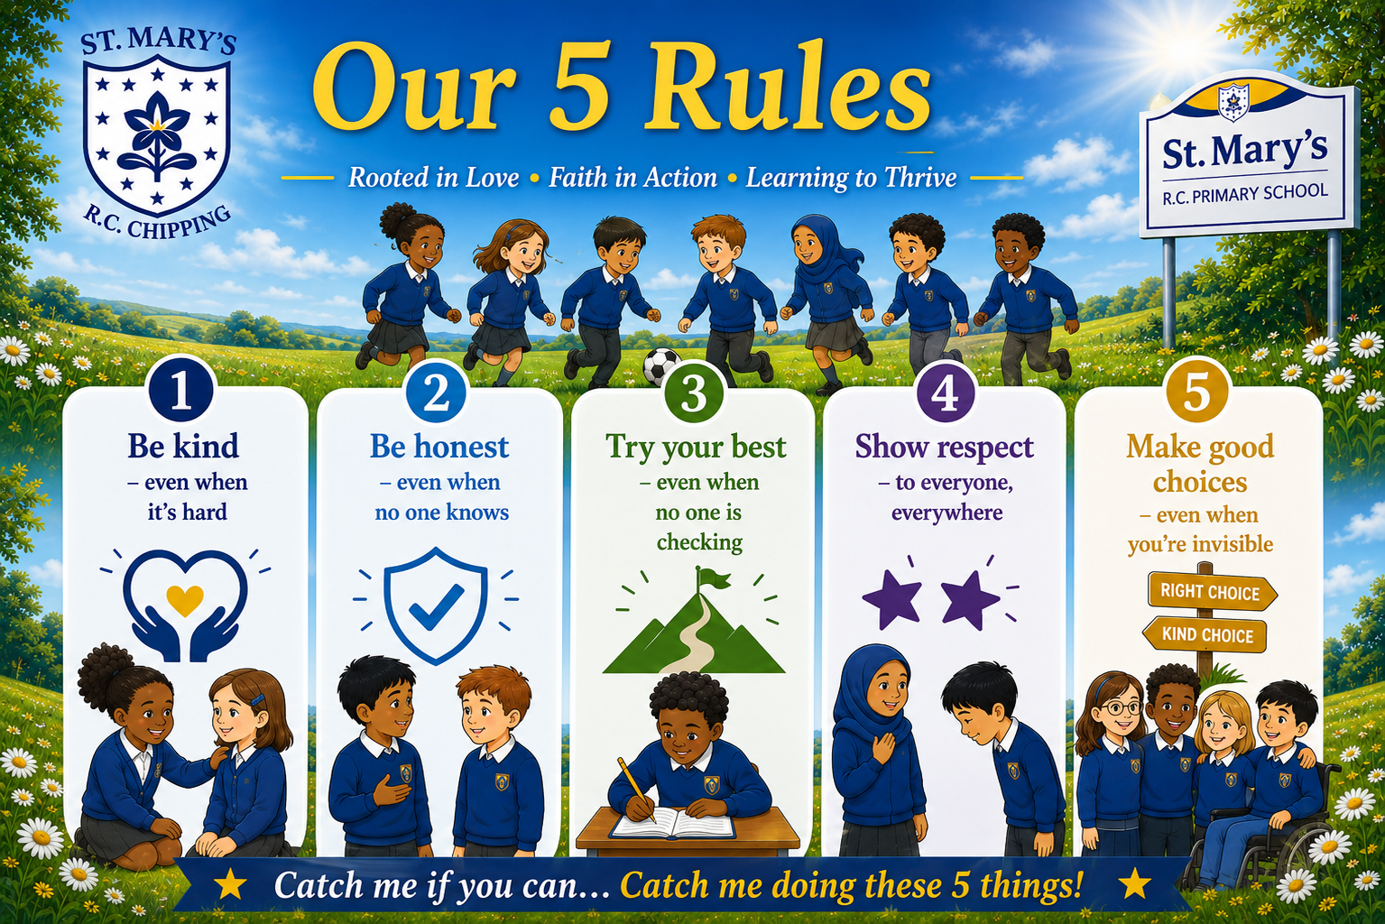

5. Relationships, belonging and adult practice
Children learn best when they feel emotionally safe, connected and valued. Staff build warm, respectful relationships, know pupils well, maintain clear boundaries and communicate with compassion.
All adults will:
- Model kindness, honesty, effort, respect and responsible choices.
- Use calm, respectful and age-appropriate language.
- Teach and maintain predictable routines.
- Apply expectations fairly and consistently while making reasonable adjustments.
- Notice early signs of difficulty and intervene supportively.
- Avoid humiliation, sarcasm, shouting and public confrontation.
- Separate the behaviour from the child and preserve dignity.
- Support co-regulation before expecting reflection or problem-solving.
- Follow through consistently and communicate relevant information to colleagues.

6. Positive recognition: Catch Me If You Can
We aim to catch children following our five rules and reinforce positive behaviours until they become secure habits. Recognition is specific, genuine and focused on effort, character, improvement and positive choices.
- Specific verbal praise
- Catch Me If You Can stickers and certificates
- Celebration assemblies
- Positive telephone calls or messages home
- Sharing achievements with other adults
- Recognition boards or class rewards
- Responsibilities and leadership opportunities

7. Responding to and supporting behaviour
Responses are relational, supportive, restorative and proportionate. Adults seek to notice difficulty early, protect safety, teach better choices and restore relationships.
Stage | Adult response
1. Notice – Praise – Encourage – Build | Notice wanted behaviour; use specific praise; reinforce expectations and build success.
2. Notice – Support – Redirect – Reassure | Approach quietly and privately; offer prompts, reassurance and redirection; reduce anxiety.
3. Stay – Protect – Reduce – Guide | Remain calm and present; prioritise safety; reduce language and demands; guide towards safe alternatives and seek support.
4. Care – Soothe – Reconnect – Reflect | Allow regulation first. When ready, support reflection, repair and a successful return.
5. Ongoing Support | Use targeted provision, reasonable adjustments, behaviour support plans, SEND support or multi-agency advice where needed.
6. Log – Monitor – Review | Record significant incidents on CPOMS; identify patterns; communicate with families; review support.

Restorative reflection
Reflection takes place only when the child is calm and ready. It is private, supportive, age-appropriate and focused on learning rather than shame. Adults may ask:
- Tell me what happened.
- Who has been affected, including you?
- How can we resolve or repair this?
- What could you do differently next time?
- What support do you need?

Serious or persistent incidents
Serious incidents, persistent disruption or behaviour that places anyone at risk may require immediate senior-leader involvement, removal from an activity, communication with parents, a risk assessment, an individual support plan, suspension or—in the most serious circumstances—permanent exclusion. Any response will be lawful, reasonable, fair and proportionate.
Significant behaviour incidents are recorded on CPOMS under the behaviour category. Patterns are reviewed. In line with the school’s operational guide, following three relevant incidents senior leaders will contact parents and speak with the child; a behaviour support plan may then be considered. Professional judgement remains necessary where an incident requires earlier action.

8. Playtimes and lunchtimes
The same expectations apply throughout the school day. Adults support safe and inclusive play through clear routines, active supervision, structured opportunities, positive recognition and restorative conversations. Relevant information is shared promptly with class teachers and senior leaders.

9. SEND, inclusion and reasonable adjustments
St Mary’s is an inclusive school. Behaviour may be affected by communication needs, sensory processing, anxiety, social and emotional needs, trauma, medical needs, neurodiversity or other SEND. We seek to understand barriers while maintaining ambitious and appropriate expectations.
Reasonable adjustments and graduated support may include:
- Adapted language, routines, resources or expectations
- Visual support, movement or sensory breaks
- Alternative regulation strategies and access to a safe space
- A trusted adult and planned key-adult check-ins
- Targeted pastoral, CBT-informed or communication interventions
- Individual behaviour, regulation or risk-management plans
- SENDCo involvement and advice from external professionals
Support plans focus on strengths, relationships, communication, regulation, safety and positive outcomes. Decisions will consider the Equality Act 2010, the SEND Code of Practice and safeguarding duties. Suspension will not be used simply because a pupil has unmet SEND needs or disability-related behaviour.

10. Restrictive interventions, including reasonable force
Policy position
Restrictive intervention is a last resort. St Mary’s prioritises prevention, early support and de-escalation. Any intervention must be lawful, necessary, proportionate, the least restrictive option and used for the shortest possible time. It must never be used as punishment.

10.1 Definitions
Term | Meaning
Restrictive intervention | An umbrella term for physical or non-physical action used to prevent, restrict or subdue movement of a pupil’s body or part of their body.
Reasonable force | Physical restrictive intervention using no more force than is necessary, for the least amount of time. What is reasonable depends on the circumstances.
Significant incident | An incident in which force goes beyond appropriate everyday physical contact between pupils and staff, including physical force used to implement a non-physical restriction.
Restraint | A non-disciplinary intervention that immobilises a pupil or limits movement, with or without direct physical contact; for example, holding a pupil’s arms or removing a walking aid.
Seclusion | A non-disciplinary intervention in which a pupil is kept away from others and prevented from leaving by obstruction or by being made to believe they will be punished if they leave.

10.2 Prevention and de-escalation
The school seeks to minimise restrictive intervention through:
- A calm, inclusive environment and explicitly taught routines
- Strong staff–pupil relationships and knowledge of individual pupils
- Early recognition of triggers and signs of distress
- Calm communication, reduced language, time and space
- Removing distressing stimuli or changing the environment
- Supporting communication and emotional regulation
- Redirection to familiar, safe and purposeful activities
- Partnership with pupils, parents and professionals
- Reviewing incident data and adapting provision

10.3 Who may use reasonable force and when?
All members of school staff have the legal power to use reasonable force in limited circumstances. Staff whom the school assesses as likely to need to use restrictive interventions will receive appropriate training in lawful and safe practice and in prevention and de-escalation. Training needs will reflect the school context and individual risk assessments.
Reasonable force may be used to prevent or stop a pupil from:
- Causing injury to themselves or another person.
- Committing a criminal offence.
- Damaging property.
- Causing disorder among pupils at school, whether during teaching or otherwise.
The decision belongs to the staff member at the time and depends on the specific circumstances. Staff must consider whether intervention is necessary, whether a less restrictive response is available, whether it is proportionate and likely to reduce rather than increase risk, and the effect on the pupil’s welfare and dignity.
Relevant factors include age, size, medical needs, SEND, communication, sensory needs, trauma, vulnerability, protected characteristics, the environment and the immediacy and seriousness of the risk. Where possible, staff will communicate calmly what is happening and why, allow processing time and continuously reassess whether the intervention can be reduced or stopped.

10.4 Unacceptable use of force
- Force must never be used as punishment.
- A pupil must not be restrained in a way that affects airway, breathing or circulation, including covering the mouth or nose or applying pressure to the neck or abdomen.
- Ground restraint carries particular risk and should be avoided. If a pupil is unintentionally held on the ground, staff must release or reposition to a safer alternative as quickly as possible.
- Any restrictive intervention must stop as soon as it is no longer necessary.

10.5 Seclusion
Seclusion is not a disciplinary sanction. It should only be used as a safety measure to protect others from harm when a pupil is experiencing high levels of emotional or behavioural dysregulation. It must not be implemented through threat of punishment.
Any place used must be safe and must not feel threatening or intimidating. The pupil must be supervised throughout and allowed to leave as soon as the immediate risk of harm has reduced. Every incident of seclusion must be recorded and reported in accordance with section 10.9.

10.6 Appropriate physical contact
St Mary’s does not operate a ‘no contact’ policy. Appropriate physical contact may include first aid; guiding or escorting a pupil; comforting a distressed child; praise such as a handshake; or demonstrating a technique in PE, music or another activity. Staff use professional judgement, follow safeguarding procedures and consider the pupil’s age, SEND, vulnerabilities, wishes and the circumstances.

10.7 Searches
The Headteacher and staff authorised by the Headteacher may search a pupil or their possessions where statutory conditions are met. Reasonable force may be used only when lawful to search for items prohibited by legislation, not solely for items banned by school rules. Staff must follow the current DfE Searching, Screening and Confiscation guidance.

10.8 Individual planning, SEND and risk assessment
Where there is an identified likelihood that reasonable force or another restrictive intervention may be required, the school must have an appropriate risk assessment and seek to mitigate risk through prevention, adjustments and training.
Where appropriate, staff will co-produce a behaviour support plan with the pupil, parents and relevant professionals. It will identify strengths, needs, triggers, communication, adjustments, prevention and de-escalation strategies, and any circumstances in which increased physical contact may be appropriate. Parameters must be clear. A plan does not remove the need to judge each incident on its individual circumstances.
Plans and risk assessments will be reviewed periodically and after any significant incident.

10.9 Recording and reporting duties
Statutory procedure
Every significant incident involving use of force, every incident of seclusion and every restraint incident—including restraint without physical contact—must be recorded in writing as soon as practicable. Staff should complete the record no later than the same day wherever possible. Parents must be informed in writing as soon as practicable, normally the same day.

The member or members of staff involved will record the incident on CPOMS and complete any additional school or local-authority record required. The written record will include, as a minimum:
- Names of the pupil and staff directly involved
- Relevant needs or circumstances, including identified SEND and SEN status
- Time, date, location and approximate duration
- What happened beforehand, including known or possible triggers
- Preventative and de-escalation strategies attempted
- Why the intervention was assessed as necessary
- The type and degree of force or restriction used
- Any injury, medical assessment or treatment
- Post-incident support and planned follow-up
Parents will receive written information including the time, date, location and approximate duration; why the intervention was necessary; the type and degree of force or restriction; and any injury. This duty applies even where possible intervention has been discussed within an agreed support plan.
The only relevant exception for primary-aged pupils is where informing a parent would be likely to cause serious harm to the pupil. In that situation, the incident must be reported to another parent where this can be done safely or, if there is none, to the local authority in which the pupil ordinarily lives. The Designated Safeguarding Lead must be involved.
Where a restraint incident is also a significant use-of-force incident, it need not be reported twice, but the record must satisfy the statutory requirements.

10.10 Post-incident support and review
As soon as practicable after an incident, the school will:
- Check the pupil and staff involved and arrange medical assessment or treatment where needed.
- Record and report injuries under school procedures and, where applicable, to the Health and Safety Executive.
- Offer separate opportunities for the pupil and staff member to reflect and receive wellbeing support.
- Where practicable, use an uninvolved adult to facilitate debriefing and relational repair.
- Consider support for pupils who witnessed an incident and were distressed.
- Review triggers, prevention, de-escalation, the impact of the intervention and what could be done differently.
- Update risk assessments and behaviour support plans where required.
- Continue to monitor pupil and staff wellbeing.

10.11 Leadership and governance oversight
The Headteacher will ensure that procedures are understood and followed. Governors will take reasonable steps to ensure compliance and will regularly review appropriately anonymised data to:
- Identify patterns, repeated incidents and opportunities for improvement
- Review whether plans and preventative strategies are effective
- Identify staff learning and training needs
- Examine any disproportionate use affecting pupils with SEND, protected characteristics or other vulnerabilities
- Assure themselves that recording, written parent reporting and post-incident support are completed

10.12 Complaints and allegations
Complaints about restrictive intervention will be considered under the school’s Complaints Procedure. Any allegation that a member of staff used force or another restrictive intervention inappropriately will be managed under Keeping Children Safe in Education and the school’s safeguarding procedures, including the procedures for allegations against staff.

11. Safeguarding and vulnerable pupils
Behaviour and safeguarding are closely linked. A change in behaviour may indicate distress, mental-health difficulty, bullying, neglect, abuse, bereavement, trauma or another safeguarding concern. Staff will follow the Safeguarding and Child Protection Policy and report concerns to the Designated Safeguarding Lead.
Children who are looked after, previously looked after, young carers or experiencing adversity may require additional support and careful consideration of known vulnerabilities.

12. Bullying
Bullying is not tolerated. It is behaviour by an individual or group, repeated over time, that intentionally hurts another individual or group. It may be physical, verbal, emotional, online, discriminatory or prejudice-related. Concerns will be taken seriously, investigated, recorded and addressed under the Anti-Bullying Policy and safeguarding procedures.

13. Suspensions and permanent exclusions
Suspension and permanent exclusion are used only when warranted and in accordance with current statutory guidance. Only the Headteacher may suspend or permanently exclude a pupil.
A decision will be lawful, reasonable, fair and proportionate and will consider safeguarding, SEND and disability, contributing factors, previous support and the impact on the education and welfare of others. Permanent exclusion will be considered only in response to a serious breach or persistent breaches of this policy and where allowing the pupil to remain would seriously harm the education or welfare of the pupil or others.
Parents will be informed without delay and provided with the required information. Reintegration after suspension will be planned carefully to support a successful return.

14. Roles and responsibilities
Role | Core responsibilities
Headteacher | Establish the culture; ensure the policy is implemented; determine serious sanctions and exclusions; oversee restrictive-intervention procedures, training, recording, reporting and review.
All staff | Teach and model expectations; build relationships; respond consistently; make reasonable adjustments; safeguard pupils; record and report concerns and significant incidents.
Pupils | Learn and follow the five rules; treat others with kindness and respect; take increasing responsibility; engage in reflection and repair.
Parents and carers | Work in partnership; share relevant information; support expectations; attend reviews and communicate concerns respectfully.
Governing body | Approve and monitor the policy; review behaviour, suspension and restrictive-intervention information; provide support and challenge; assure statutory compliance.

15. Monitoring, evaluation and review
School leaders monitor behaviour through CPOMS, safeguarding records, pupil and parent voice, staff feedback, attendance, suspension and exclusion information, SEND information and restrictive-intervention records. Governors receive proportionate, anonymised information and consider fairness, consistency, trends and impact.
This policy will be reviewed annually and sooner if legislation, statutory guidance, local-authority advice, school context or evaluation indicates that change is required.

16. Legal and guidance framework
- Education and Inspections Act 2006, including sections 89, 93 and 93A
- Schools (Recording and Reporting of Seclusion and Restraint) (No. 2) (England) Regulations 2025
- Equality Act 2010
- Human Rights Act 1998
- Health and Safety at Work etc. Act 1974
- Children and Families Act 2014 and SEND Code of Practice
- DfE Behaviour in Schools
- DfE Restrictive Interventions, Including Use of Reasonable Force, in Schools (effective 1 April 2026)
- DfE Searching, Screening and Confiscation at School
- DfE Suspension and Permanent Exclusion
- Keeping Children Safe in Education
- EEF Improving Behaviour in Schools

Appendix A: Responding to and Supporting Behaviour
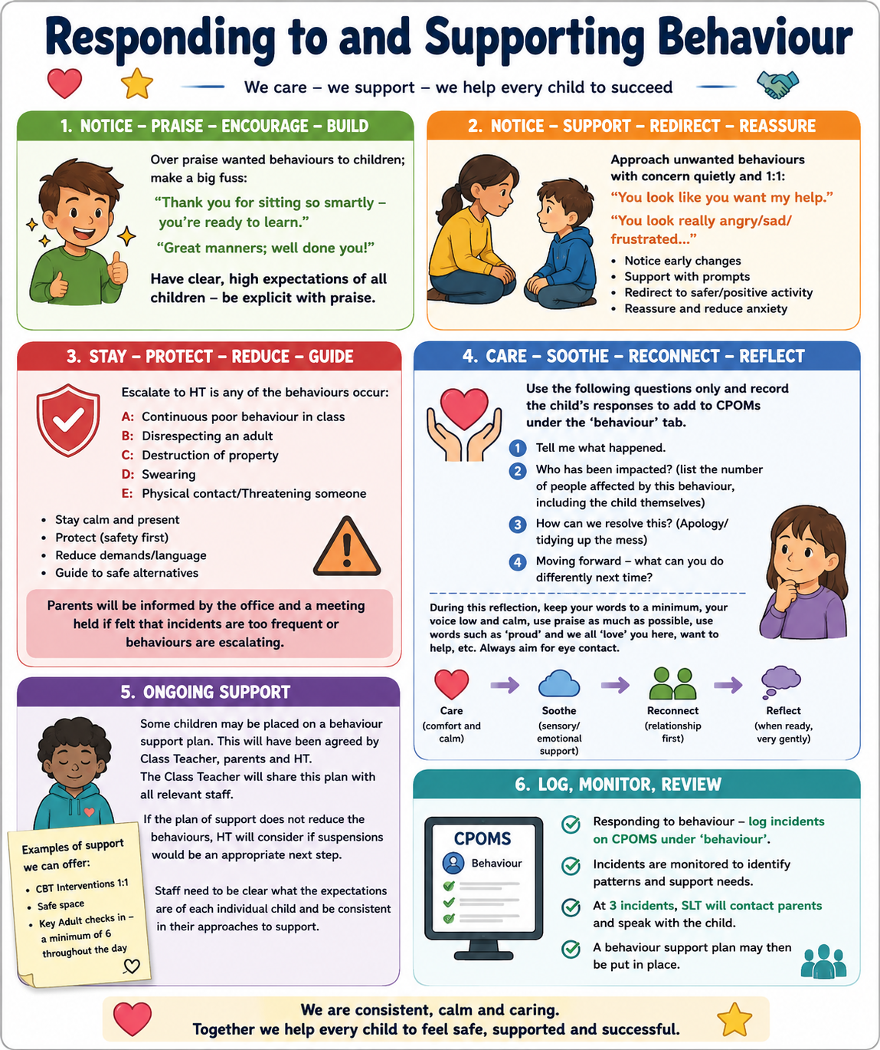

Appendix B: Restorative scripts

Questions
- Tell me what happened.
- What were you feeling?
- Who has been affected, including you?
- How can we put things right?
- What could you do differently next time?
- What support do you need?

Calm adult scripts
- I’m here to help.
- You are safe.
- I can see that you are finding this difficult.
- Let’s solve this together.
- Take the time you need; we will talk when you are ready.
- Thank you for making a safer choice.

Appendix C: Minimum restrictive-intervention record
The school record must enable staff and leaders to evidence:
- Pupil and staff names
- SEND status, medical information and relevant vulnerabilities
- Date, time, location and duration
- Antecedent, context and possible triggers
- Prevention and de-escalation attempted
- Reason intervention was necessary
- Type and degree of force, restraint or seclusion
- How the pupil’s welfare and dignity were considered
- Injuries, medical checks and treatment
- Pupil, staff and witness accounts where appropriate
- Post-incident support and relational repair
- Date, time and method of written parent notification
- Leadership review and actions
- Risk-assessment or support-plan review

Document approval
Approved by
Signature
Date
Next review | July 2027

