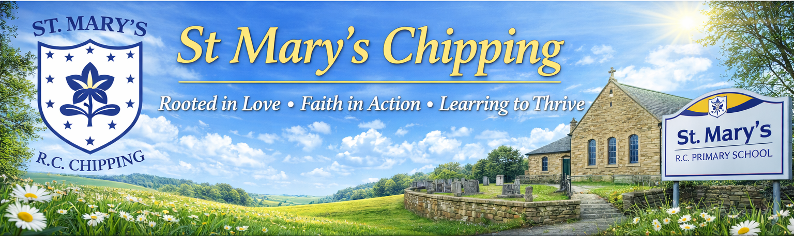

Welcome to our June Newsletter!
We hope you all had a wonderful half-term break and enjoyed the lovely sunshine.
We have an exciting and busy few weeks ahead as we work towards a successful end to the year. There will be lots of opportunities for learning, celebration, and making special memories together. We will also be preparing to say a fond farewell to our Year 6 pupils as they complete their primary school journey and embark on their next exciting chapter at high school.
Please take a moment to read through the dates and information in this newsletter carefully to ensure you don't miss any important events and activities.
We look forward to a fantastic final half term with all of our children and families. ☀️📚🎉


📅 Diary Dates for June

9th June Sports Day 1:30pm
18th June Teddy Bear’s Picnic
22nd June Lock Learner’s
Maths Day for KS2
23rd June Y6 Treat Day
30th June Open the Book
Careers Week
We are looking forward to an exciting Careers Week, beginning w/c 8th June, with a range of engaging activities planned for all year groups.
Children will take part in experiences such as city role play, a special visit from a British Airways pilot, and an enterprise project for our Year 6 pupils with a special guest – along with many more exciting opportunities to inspire their future ambitions.
To celebrate the week, on the final day (Friday 12th June), children are invited to come to school dressed as “When I grow up, I want to be…”.
We would also love to involve our school community. If you would be willing to come into school to talk about your profession, or know someone who could, please let Mrs Jones know.
We look forward to a fantastic and inspiring week!

Attendance
St Mary’s Attendance: 94.03%
National Attendance: 93.32%
Good attendance is essential for children to achieve their best. Even a short absence can have a significant impact on learning – for example, missing one week of school means around 25 hours of learning is lost, which can create gaps in knowledge and affect progress.
Click the link to see the real impact of low attendance—on learning, wellbeing, and future life chances.
https://educationhub.blog.gov.uk/2025/08/why-school-attendance-matters-and-what-were-doing-to-improve-it/

Congratulations
A huge congratulations to Miss Bennett who has announced her pregnancy. We are all delighted for her and her family and can’t wait to meet baby in November.




Teddy Bears' Picnic Fundraiser for Brian House Children's Hospice

We are delighted to be supporting Brian House Children's Hospice with a
special Teddy Bears' Picnic Fundraiser on Thursday 18th June.
On this exciting day, children are invited to bring their favourite teddy
bear to school and take part in a range of fun activities, including a
30-minute exercise challenge and a picnic outdoors (weather permitting).
Sponsorship forms will be sent home nearer the time, and we would be very grateful for any donations to help us raise as much money as possible for this wonderful cause.
Children are welcome to come to school in non-uniform. We recommend sports clothing and trainers so that they can take part comfortably in all activities.
Thank you for your support in helping us make a difference for the children and families supported by Brian House Children's Hospice.

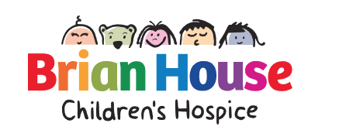

22nd June – Lock Learners Maths Workshop (KS2)
We are excited to welcome Lock Learners to school on 22nd June for a special workshop with all KS2 children. Through a range of fun, interactive challenges and activities, pupils will develop their mathematical thinking, problem-solving skills, and confidence in an engaging and enjoyable way. The workshop aims to show children that maths can be exciting, accessible, and enjoyable for everyone, helping to build positive attitudes towards the subject and remove any fears or anxieties they may have about learning maths.



