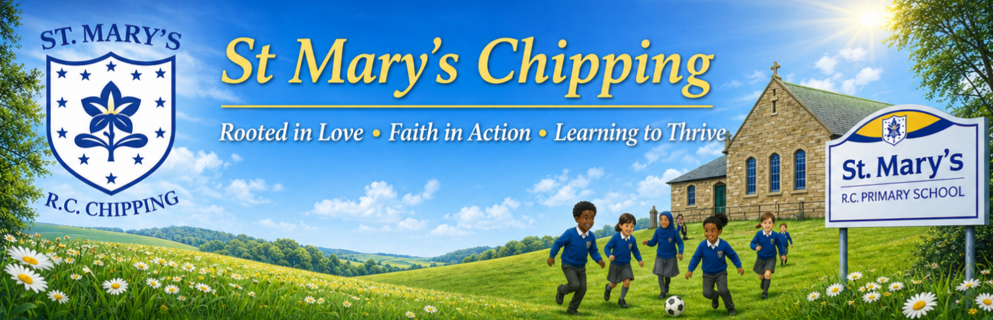

Welcome to our October Newsletter!
It’s hard to believe we are already in October! We’ve had a busy and positive start to the new school year, with lots happening across St Mary’s.
In this month’s newsletter, you’ll find some of our latest news, important dates and updates from school.
We’re also delighted to share our new-look school website, which has been updated with lots of useful information about school life, our curriculum, Catholic life and what makes St Mary’s such a special place.
Visit here: https://www.st-marys-chipping.lancs.sch.uk/
Thank you, as always, for your continued support.

Thank You – Getting Involved at St Mary’s
A big thank you to all the parents who attended our recent Working Party meeting. It was wonderful to see so much enthusiasm and support for our school.
Our PTFA will soon be up and running, with an introductory meeting currently being planned. If you would like to be involved but couldn’t attend the Working Party meeting, please let us know. We can take your email address and pass it on to the Chair of the PTFA, who will keep you updated.
We’ve already had a parent come forward and offer to help us run a school choir, which is fantastic! 🎶 If you have a skill, hobby or a little time that you could share with our children – or you would simply like to help with school activities and events – please get in touch. We would love to hear from you!
Thank you for helping us make St Mary’s an even stronger school community.

📅 Dates for the Diary
October:
12th – 14th Y4/5/6 Residential
to Winmarleigh
14th – 21st Book Fair in school

14th Firework Safety Talk

15th Open Day

20th Parent’s Evening

23rd INSET DAY
SCHOOL CLOSED

Half term: 26th – 30th October
School Reopens Monday 2nd November


📚 Parents’ Evening Reminder
Don’t forget to book your Parents’ Evening appointment. It’s a lovely opportunity to meet with your child’s class teacher, look through their books and see just how busy they have been already this year!
You’ll also hear how well they have settled into their new class and how they are getting on with their learning. 💙

Attendance
St Mary’s Attendance: 94.56%
National Attendance: 93.07%

Please Spread the Word – Open Day
Our Open Day is on Thursday 15th October and we would love your help in spreading the word!
If you know any families who are looking for a Reception place for September 2027 or are interested in a place in our Pre-School, please encourage them to come along and discover what makes St Mary’s such a special place to learn and grow.
Please share with friends, family and anyone in the local community who may be interested. Every share and recommendation really does help our growing small school! 💙

⚽ Sporting Success
A brilliant start to our sporting year! 4th place in the Kids Cup Football Tournament and 1st place at Mini Skills! 🏆 Well done to everyone who represented St Mary’s so proudly.
Next up – Y3/4 Mini Skills! Good luck! 💙

