












Working together with parents to support…
Potty training

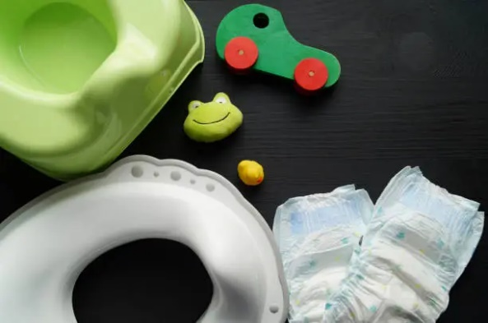

Why Toilet Training is Important
Mastering the skill or using the toilet or potty supports:
- children's growing independence
- physical awareness and body confidence
- social confidence with their peers
- being ready for future routines such as starting school
Toilet and Potty Training
Learning to use the potty or toilet is an important developmental milestone just like sleep routines. It works best when parents and settings work together with a shared approach. Children make the best progress when expectations of them are consistent and led by parents or carers at home.

When home and settings work in partnership, children feel secure, confident and ready for this next step in independence.

Working Together
Your child's toileting journey begins at home. This should typically be between the ages of 18 and 30 months. Daily routines, consistent expectation and responsive support help with successful learning.
Sharing information with your child's key person helps to:
- understand your child's readiness
- use familiar cues and language from home
- offer encouragement and consistency
- support your child sensitively during accidents or setbacks
The more we share – the smoother the experience will be for your child.

Things to consider
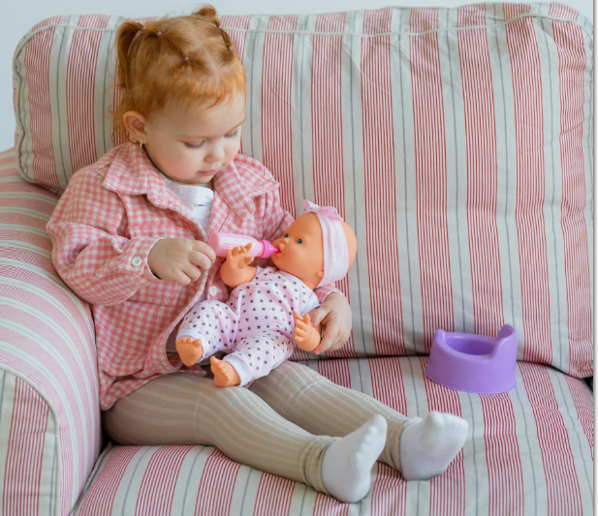
If you’re worried or unsure?
Speak to your GP or Health Visitor for concerns about constipation, withholding, anxiety, or additional needs.

Accidents happen
Accidents are a normal part of learning a new skill. Parents should provide several full sets of spare clothing when potty training.
Parents should make sure that children have easy to pull down clothing to support their independence when using the toilet.
What settings can't do
To maintain safety for all children the setting would be unable to:
- keep children out of nappies before they are ready
- take children to the toilet every few minutes
- follow the child constantly
- toilet train a child without home being fully involved

What settings can do to support potty training
- encourage toilet use as part of normal routines
- offer reminders and gently prompts
- keep open communication with you about progress
What parents can do at home
Toilet training requires consistency, patience and time. Parents can support this by:
- choosing a time when you can stay home for the first few days
- removing nappies during awake times
- offering regular chances to use the potty or toilet
- reassuring your child when accidents happen
- ensuring your child is not constipated
- encouraging your child to notice their bodily signals
Children learn best when steps are small, consistent and positive.

Be mindful that:
- nurseries and childminders must follow the Early Years Foundation Stage Statutory Framework for health, hygiene and safety requirements
- practitioners must remain available to supervise all children
- practitioners must consider the safety and privacy of all children

