












Working together with parents to support …
Your child's settling-in journey
Supporting your child to feel confident and ready to thrive

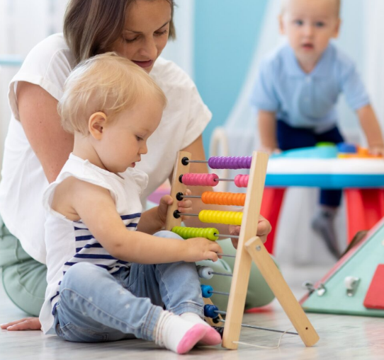

The Science Behind Settling In
Children thrive when relationships are warm, responsive and consistent. A gradual transition, led by a named key person, supports emotional regulation and reduces stress. Short, supported visits allow your child to build trust at their own pace before moving to longer sessions.

- Children rely on familiar adults to regulate emotions and to feel confident exploring new places.
- Positive, predictable relationships support healthy brain development.
- Gradual introduction helps to reduces stress, making adaptation easier.
- Following simple, consistent routines helps children understand what comes next and builds their confidence.
Working at a pace that works for the child
A thoughtful settling-in process helps children build trust, feel secure and confidently adjust to a new environment.
Every child is different, some settle quickly whilst others may take more time. The aim is to work together, at a pace that supports your child whilst continuing care for all children.
Why settling-in matters
Starting at a setting is a significant step for children and families. Settling-in sessions give your child time to get to know their new environment, routines and the adults who will care for them. These early experiences lay the foundations for confidence, independence and a positive start to learning.

Settling in sessions help children feel
- Safe – familiar faces and predictable routines reduce anxiety
- Secure – a trusted adult (key person) becomes their 'secure base'
- Ready to learn – once children feel safe, they can explore and engage.

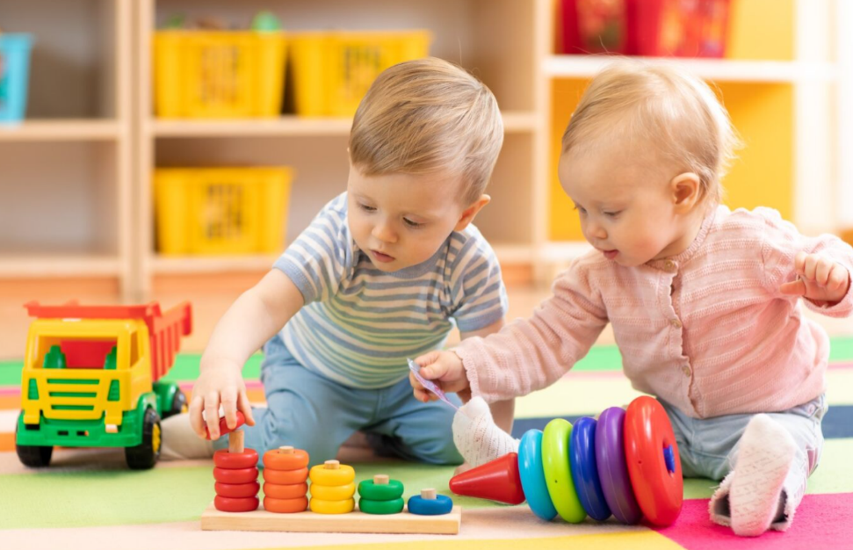
Let's work together
Parents and practitioners share the same goal, a child who feels safe, understood and ready to thrive. Open, honest communication helps to tailor the settling-in process.
- During early sessions, a calm, reassuring presence helps children feel secure.
- Knowledge about routines, comfort items and interests helps to build a picture of the child.
- If the child has any worries then they can be supported through these.

Emotions are contagious and children pick up on adult feelings. A calm, confident drop-off helps children feel secure.

Children may need more support than others as every child's settling-in journey is unique. While some children adapt quickly, others may need additional time, reassurance and a more gradual transition. Settling-in plans will be adapted to meet individual needs.

Children respond differently to new environments and some take longer to settle than others and this is completely normal. Their behaviour may change temporarily. You may see being clingier or more attached. They may even cry more. Children are experiencing new environments and surroundings and with this comes new feelings and possible unsettledness.

Policies and procedures
To make sure care is safe, consistent and responsive, settling-in approaches follow the Early Years Foundation Stage (EYFS) requirements and setting policies.
- A names key person is assigned to every child and will be your main point of contact.
- Settling-in sessions are arranged in advance and tailored to individual needs.
- Staffing ratios and safeguarding procedures are always followed
- Practice is evidence-informed and focused on children's emotional wellbeing.
Things to consider

