












Working together with parents …
Supporting children's risk taking and everyday accidents

Encouraging Safe Exploration in Nursery Settings
Children learn best through active exploration, movement, and trying things out for themselves. This naturally includes moments of managed risk, such as climbing, balancing, running, or using new equipment. All of which help children develop confidence, resilience, and problem-solving skills.
Nursery environments are designed to be stimulating, developmentally appropriate, and safe, but they can never be entirely free from bumps, slips, and minor accidents. These small incidents are a normal part of early childhood and often play an important role in helping children understand their own abilities and the world around them.


Why Risk-Taking Matters
Young children build key skills by experiencing appropriate challenge. Through supervised risk-taking, children learn to develop independence. Enabling children to practise doing things for themselves such as climbing steps, navigating outdoor spaces, carrying items, and making decisions can really help their development. They learn balance, control, coordination and also begin to assess what feels safe for them.

These developmental benefits mean that risk-free environments can actually limit children’s learning. Instead, early years practitioners create spaces that include 'managed risk' environments that allow children to be challenged whilst ensuring safety measures are in place.

Everyday Accidents: What Parents Can Expect
In busy, active nursery environments, it’s normal for children to experience:
- Bumps or minor knocks
- Trips or slips
- Small cuts, scrapes, or bruises
- Accidental collisions with equipment or peers
These typically happen during ordinary play and exploration such as running outdoors, climbing, moving quickly, trying something new, or simply learning how to move in a group environment. Settings are required to ensure that practitioners are trained to respond calmly and promptly, providing comfort, first aid where needed, and emotional reassurance. It is a statutory requirement to inform parents of any accidents and the support given, so parents will always be aware if any accident occurs.

.

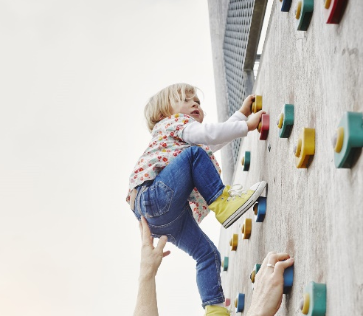

Let's Work Together
By approaching risk as something to be managed, not avoided, we help children:
- Feel safe and supported
- Develop essential life skills
- Build independence and confidence
- Enjoy a rich and meaningful early years experience
Through openness, flexibility, and trust, we can partner effectively to create safe, joyful environments where children thrive.

Things to consider
Understanding that minor bumps and slips are a typical part of early learning and exploration is central to child development. As children learn to move confidently and take appropriate risks, occasional bumps, scrapes, and slips are normal and expected. In fact, they are part of how children learn to judge distances, understand how their bodies move, solve problems and build resilience.
Settings are designed to reduce serious risk, not to eliminate all challenge. Recognising that small accidents are part of healthy development helps everyone stay aligned and reassured.

Trusting practitioners’ professional judgement supports strong partnership working. Staff make decisions based on training, experience, and their knowledge of the group, including when to step back to allow independence and when to intervene to keep children safe.

Recognising that nurseries cannot and should not remove all risk helps children benefit from appropriate challenge. Children need opportunities to try things, make decisions, and occasionally make mistakes to develop confidence, coordination, and independence.

When parents and practitioners work in partnership, sharing information, trusting one another, and understanding the value of managed risk, children benefit enormously. They learn:
- That they are supported
- That adults believe in their abilities
- That it’s okay to try, practise, wobble, and try again
- That challenges can be exciting, not frightening
Together, by sharing information, communicating openly, and understanding the value of managed risk, we help children grow into capable, resilient individuals who feel supported, confident, and proud of what they can achieve.
Asking questions whenever you are unsure about an activity, incident, or approach helps keep communication open. Practitioners are always happy to explain how an accident occurred, what supervision looked like, or why certain forms of managed risk are encouraged.

