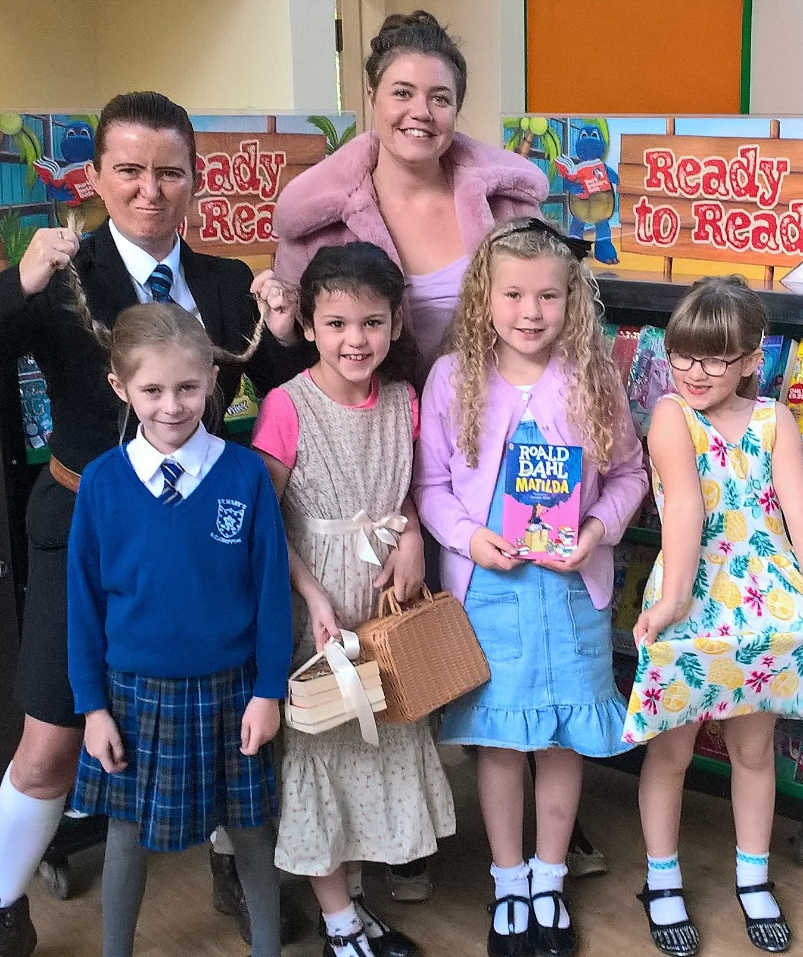
Bag Packing at Sainsburys Sat 22nd Sep

The children in years 3 up to 6 have been asked if they could volunteer to bag pack for an hour next Saturday morning at Sainsbury’s, Longridge to help raise funds for the Armistice Production that we are taking part in. We need about 8 children if possible. Please see accompanying letter.

Nominations for Parent Governor

Please return your interest if you would like to be put forward for parent governor before next Monday lunchtime (24th Sep) If there is more than one candidate, it will then go out to ballot.
Pre-school Meeting Wed 19th Sep

We have decided to post-pone our meeting on Wed for pre-school till later in the term. Some of our parents felt that they didn’t need a meeting just yet. However, if you have any questions please do not hesitate to contact the office or speak to Miss Taylor and Mrs Hutchings.
Special Events and Assemblies

Please see the list of special events and assemblies attached to this email and on the back of the hard copy of this newsletter. Our first special event is the MacMillan coffee afternoon on Friday 28th September from 2pm onwards. Any donations of cakes would be greatly appreciated. We would like to dedicate the coffee afternoon to Doreen Bailey who was a huge part of our school as a parent, grand-parent and governor and will be sadly missed by many people. Please do come along if you can.

It is whole school Mass on Thursday 27th Sep at 9.30am. Father Tony will be coming into school after Mass to spend the morning with us getting to know everyone. We look forward to meeting with him.

Roald Dahl Day and Book Fair

Thank you to all the children who came to school in their Roald Dahl book character costumes last Thursday. The children looked fantastic and it was a great start to having the Book Fair in school. The Book Fair will continue to be in the library after school until Wednesday. Thank you to everyone who has already bought books – the school takes commission on what we sell so it’s a win win for all.

Reading Festival
The children from years 2 up to year 6 will be going to Longridge High School this Thursday to take part in a reading festival with other primary schools from Longridge. Please can all children in these year groups bring a packed lunch. We will leave after registration and be back in school for 3.15pm. Please see attached letter about the visiting authors.

